UNIVERSITY OF CALGARY

Studying Network Variants With Electroencephalography

by

Michael McCarthy

A THESIS

SUBMITTED TO THE FACULTY OF GRADUATE STUDIES

IN PARTIAL FULFILMENT OF THE REQUIREMENTS FOR THE

DEGREE OF MASTER OF SCIENCE

GRADUATE PROGRAM IN PSYCHOLOGY

CALGARY, ALBERTA

OCTOBER, 2022

© Michael McCarthy 2022

Abstract

The study of network variants, individual-specific deviations in whole brain functional network organization, is an area of growing interest in human neuroscience due to its relevance for understanding *how much* and *in which ways* whole brain functional networks differ between and within individuals. Although previous research has mainly relied on highly sampled functional magnetic resonance imaging (fMRI) data to study network variants, electroencephalography (EEG) has the potential to deliver complimentary insights given that it directly measures the electrophysiological activity of neural populations in the cerebral cortex in real time. Here we explored the feasibility of using EEG to study network variants using repeated measures eyes-closed and eyes-open resting state data from 14 participants taken across three sessions—testing for the presence of network variants by estimating how phase and amplitude coupling functional connectomes differ between and within individuals across different frequency bands using measures of network similarity, contrasting the magnitude of each of these effects across sessions and states at the group-level, and examining their consistency at the individual-level. We found at most weak supportive evidence for the presence of network variants in a subset of our sample for phase coupling functional connectomes in the theta, alpha, beta, and gamma bands, but did not generally demonstrate the feasibility of using EEG to study network variants given the inconsistencies observed across participants.

*Keywords:* Electroencephalography, Functional Connectivity, Network Variants, Individual Differences

Preface

This thesis is original, unpublished, independent work by the author, M. McCarthy.

Acknowledgements

I thank my supervisor, Dr. Andrea Protzner, for her guidance, mentorship, and support throughout my degree and thesis, my committee members, Dr. Penny Pexman and Dr. Signe Bray, for their feedback on my thesis proposal, and Dr. Ford Burles for training me to work with EEG data. I also thank my father, Gord, my brother, Branden, and my grandparents, Joan and Walter, for their love and support—I could not have achieved all that I have without you.

This research was supported by funding received through the Natural Sciences and Engineering Research Council (NSERC) Canada Graduate Scholarship; University of Calgary Faculty of Graduate Studies Master’s Research Scholarship and Graduate Studies Scholarship; and Alberta Graduate Excellence Scholarships (AGES) Master’s Research Scholarship.

Table of Contents

Abstract ii

Preface iii

Acknowledgements iv

Table of Contents v

Introduction 1

Methods 8

Data 8

Software and computational reproducibility 10

EEG preprocessing 11

Analyses 13

Results 22

Overview 22

Delta band 23

Theta band 28

Alpha band 32

Beta band 37

Gamma band 41

Discussion 45

Differences between phase and amplitude coupling 46

Consistency with related neurophysiological connectomics literature 48

Factors that may contribute to differences between EEG and fMRI 50

Limitations 53

Conclusion 55

References 57

Appendix A 80

Appendix B 86

Studying Network Variants with Electroencephalography

# Introduction

A central goal of modern neuroscience is to identify the neural causes of variation in human behaviour and cognition by characterizing how whole brain functional networks differ between and within individuals under a variety of conditions (Dubois & Adolphs, 2016; Sporns, Tononi, & Kötter, 2005; Van Essen et al., 2012; see also, Sauce & Matzel, 2013). The coupling of neural oscillations between spatially separate brain regions to form functional networks is considered a key mechanism by which the brain transmits and processes information (Buzsáki, 2011; Buzsáki & Draguhn, 2004; Garrett et al., 2013; Schnitzler & Gross, 2005), and studying individual differences in the strength and pattern of connectivity in these functional networks is thought to be important for answering long-standing questions about behaviour and cognition in neuroscience (e.g., Viola, 2020), psychology (e.g., McFarland, 2017), and medicine (e.g., Gratton et al., 2020). Large and small scale efforts are now being made to characterize how whole brain functional networks differ between and within individuals (for examples of large scale efforts, see Alexander et al., 2017; Van Essen et al., 2012; for examples of small scale efforts, see Gordon et al., 2017; Poldrack et al., 2015), and it is anticipated that the results of these efforts will lead to more robust and replicable accounts of human behaviour, cognition, and their dysfunction (Elliott et al., 2020; Fedorenko, 2021; Marek et al., 2020; cf. Mehler & Kording, 2020; cf. Sloman, Patterson, & Barbey, 2021).

Given the promise of these efforts, it is unsurprising to see individual-level approaches being used to investigate how whole brain functional networks change across the lifespan (M. Y. Chan et al., 2021), respond to changing conditions (Gratton et al., 2018), predict differences in behaviour and cognition (Finn et al., 2015), reflect dysfunction in behaviour and cognition (Kebets et al., 2021), and reorganize with brain damage or disease (Laumann et al., 2021). Nor is it surprising to see this knowledge applied in areas as diverse as personalized psychiatric treatment (Gratton et al., 2020), surgical planning (Tie et al., 2014), deep brain stimulation (Scangos et al., 2021), biometric security (H.-L. Chan, Kuo, Cheng, & Chen, 2018), and biomarker discovery (Sorrentino et al., 2020).

An important question underlying each of these investigations—both for its practical and theoretical consequences—is *how much* and *in which ways* whole brain functional networks differ between and within individuals. Much of the current progress in this area comes from the study of spontaneous fluctuations in blood oxygenation level dependent (BOLD) signals recorded with functional magnetic resonance imaging (fMRI), which provide an indirect measure of brain activity though the process of neurovascular coupling (Hillman, 2014). Recent investigations using fMRI have revealed that although whole brain functional networks share common organizing principles between individuals, there is an approximately equal amount of unshared organization (Gratton et al., 2018). These individual-specific deviations in whole brain functional network organization are commonly referred to as *network variants* (Seitzman et al., 2019). Importantly, comparisons between individuals have found that individuals can be reliably separated into subgroups based on similar distributions of network variants, suggesting that network variants may be trait-like (Gordon, Laumann, Adeyemo, & Petersen, 2017; Gratton et al., 2018; Seitzman et al., 2019); and comparisons within individuals have indicated that network variants are highly stable, with their organization being influenced only moderately by behavioural or cognitive state and mildly by time (Gratton et al., 2018; Seitzman et al., 2019).

The neural causes of network variants and their stable trait-like features are not yet known; however, current evidence suggests that they may reflect underlying structural networks and individual-specific subnetworks with long-term histories of coactivations between areas (see Gordon et al., 2021; Greene et al., 2020). Moreover, both network variants and their clusters also appear to be behaviourally and cognitively relevant, as a number of studies have demonstrated they are predictive of individual differences in behaviour and cognition (Finn & Bandettini, 2020; Finn et al., 2020; Finn et al., 2017, e.g., 2015).

In order to observe network variants reliably, previous research has used highly sampled fMRI data analyzed within individuals prior to making comparisons between individuals (Elliott et al., 2019, cf. 2020; Gordon et al., 2017; Laumann et al., 2015). Analyzing data without this first step, for example by averaging activation maps across individuals voxel-wise, will obscure network variants, leaving only what is common between individuals (Gratton et al., 2018; Speelman & McGann, 2013). This may cause substantial and relevant portions of variability in whole brain functional networks to be overlooked (Gratton et al., 2018), resulting in unreliable inferences about the ways in which whole brain functional networks differ between individuals (Elliott et al., 2020). Similarly, although the common features of whole brain functional networks can typically be detected with 5-10 minutes of fMRI data when averaging across individuals, more than 25 minutes of data (collected continuously or across multiple scans) are needed to reliably detect network variants (Anderson, Ferguson, Lopez-Larson, & Yurgelun-Todd, 2011; Elliott et al., 2019; Gordon et al., 2017; Hacker et al., 2013; Laumann et al., 2015). Due to the high cost of scan times, this level of measurement is not feasible for a majority of labs collecting their own data (Elliott et al., 2019). In sum, network variants offer a promising new direction to understand network function, but the conditions required to study them reliably using fMRI are a considerable practical barrier.

A natural solution to this barrier is to explore the feasibility of lower cost neuroimaging modalities for studying network variants. Electroencephalography (EEG) offers one such solution. EEG directly measures the electrophysiological activity of neural populations in the cerebral cortex in real time (Cohen, 2014, 2017; Luck, 2014). It allows us to directly probe the synchronization of neural oscillations in functional networks, bypassing the complexities of linking BOLD signals to the dynamics of underlying neural activity. It also allows us to measure neural oscillations at timescales much faster than the infraslow 0.1 Hz oscillations of BOLD signals, making it possible to test whether the organization of network variants is sensitive to timescales (cf., Mostame & Sadaghiani, 2021). There is currently debate about whether functional network organization is sensitive to timescales (see Sadaghiani & Wirsich, 2020). One view predicts frequency-specific functional specialization of networks, and is supported by findings that connectivity in different frequency bands has been linked to different neural processes (e.g., Sadaghiani & Kleinschmidt, 2016) and is more prominent in different brain regions following a medial-to-lateral and posterior-to-anterior gradient of increasing frequency (Capilla et al., 2022). The other view predicts that functional network organization is timescale-invariant, and is supported by computational models that suggest functional networks have a common organization across timescales when averaged over sufficiently long periods (Sadaghiani & Wirsich, 2020).

There are two disadvantages to EEG that may pose a challenge for identifying network variants. First, the effects of field spread and volume conduction in the head can cause multiple electrodes to record activity from the same underlying neural source (Nunez & Srinivasan, 2006; Schoffelen & Gross, 2009), resulting in spurious estimates of connectivity between regions in functional networks. This can be addressed either through source reconstruction methods, which attempt to unmix measured signals to estimate the location of the underlying neural sources; or by using connectivity metrics that account for the effects of field spread and volume conduction in the head, which reduce the possibility of spurious coupling between channels from influencing functional connectivity estimates (Bastos & Schoffelen, 2016). Second, EEG is generally limited to measuring cortical neural activity and has poor spatial resolution compared to fMRI. Despite these challenges, numerous studies have demonstrated that measures of electrophysiological connectivity show spatial similarity to the functional connectivity commonly observed with fMRI regardless of timescale (Daniel Arzate-Mena et al., 2022; Sadaghiani & Wirsich, 2020). Given this, network variants may also be identifiable with EEG. However, the vast majority of work using EEG to study whole brain functional networks focuses on group-level approaches, so the feasibility of using EEG to study network variants is largely unknown.

Here, we use EEG data previously collected by our lab as part of a larger study—containing a total of 30 minutes eyes open resting state data (over 6 recordings) and 30 minutes eyes closed resting state data (over 6 recordings) from each participant—to answer this question. First we create a functional connectome from each recording by estimating the phase and amplitude coupling between all pairs of EEG channels. Phase and amplitude coupling are thought to reflect different but related neurophysiological functions and it is common to use both measures so they can be compared (Engel, Gerloff, Hilgetag, & Nolte, 2013; Sadaghiani & Wirsich, 2020; Wirsich et al., 2021). Specifically, phase coupling is thought to regulate the integration and flow of cognitive contents on fast timescales, and amplitude coupling is thought to coordinate changes in (co)activation of brain areas on slow timescales (Engel et al., 2013). Then we test for the presence of network variants by estimating how functional connectomes differ between and within individuals using measures of network similarity.

Figure 1 depicts six archetypal outcomes we could find. The first column shows outcomes that would occur in cases where functional connectomes *do not* differ between individuals. In particular, we might expect to see (1) a *group effect* with high similarity among all measurements regardless of individual, session, or state, which might occur if the brain activity we measured is largely intrinsic and common across individuals (cf. Raichle, 2010); (2) a *session effect* with high similarity among all measurements regardless of individual or state, but not session, which might occur if the brain activity we measured is largely intrinsic, common across individuals, and varies over time in the same way across individuals; or (3) a *state effect* with high similarity among all measurements regardless of individual or session, but not state, which might occur if the brain activity we measured is largely reactive in a way that is common across individuals (cf. Raichle, 2010). The second column shows outcomes that would occur in cases where functional connectomes *do* differ between individuals. In particular, we might expect to see (4) an *individual effect* with high similarity among all measurements regardless of session or state, but not individual, which might occur if the brain activity we measured is largely intrinsic and unique within individuals; (5) an *individual-session effect* with high similarity among all measurements regardless of state, but not individual or session, which might occur if the brain activity we measured is largely intrinsic, unique within individuals, and varies over time within individuals; or (6) an *individual-state effect* with high similarity among all measurements regardless of session, but not individual or state, which might occur if the brain activity we measured is largely reactive in a way that is unique within individuals.

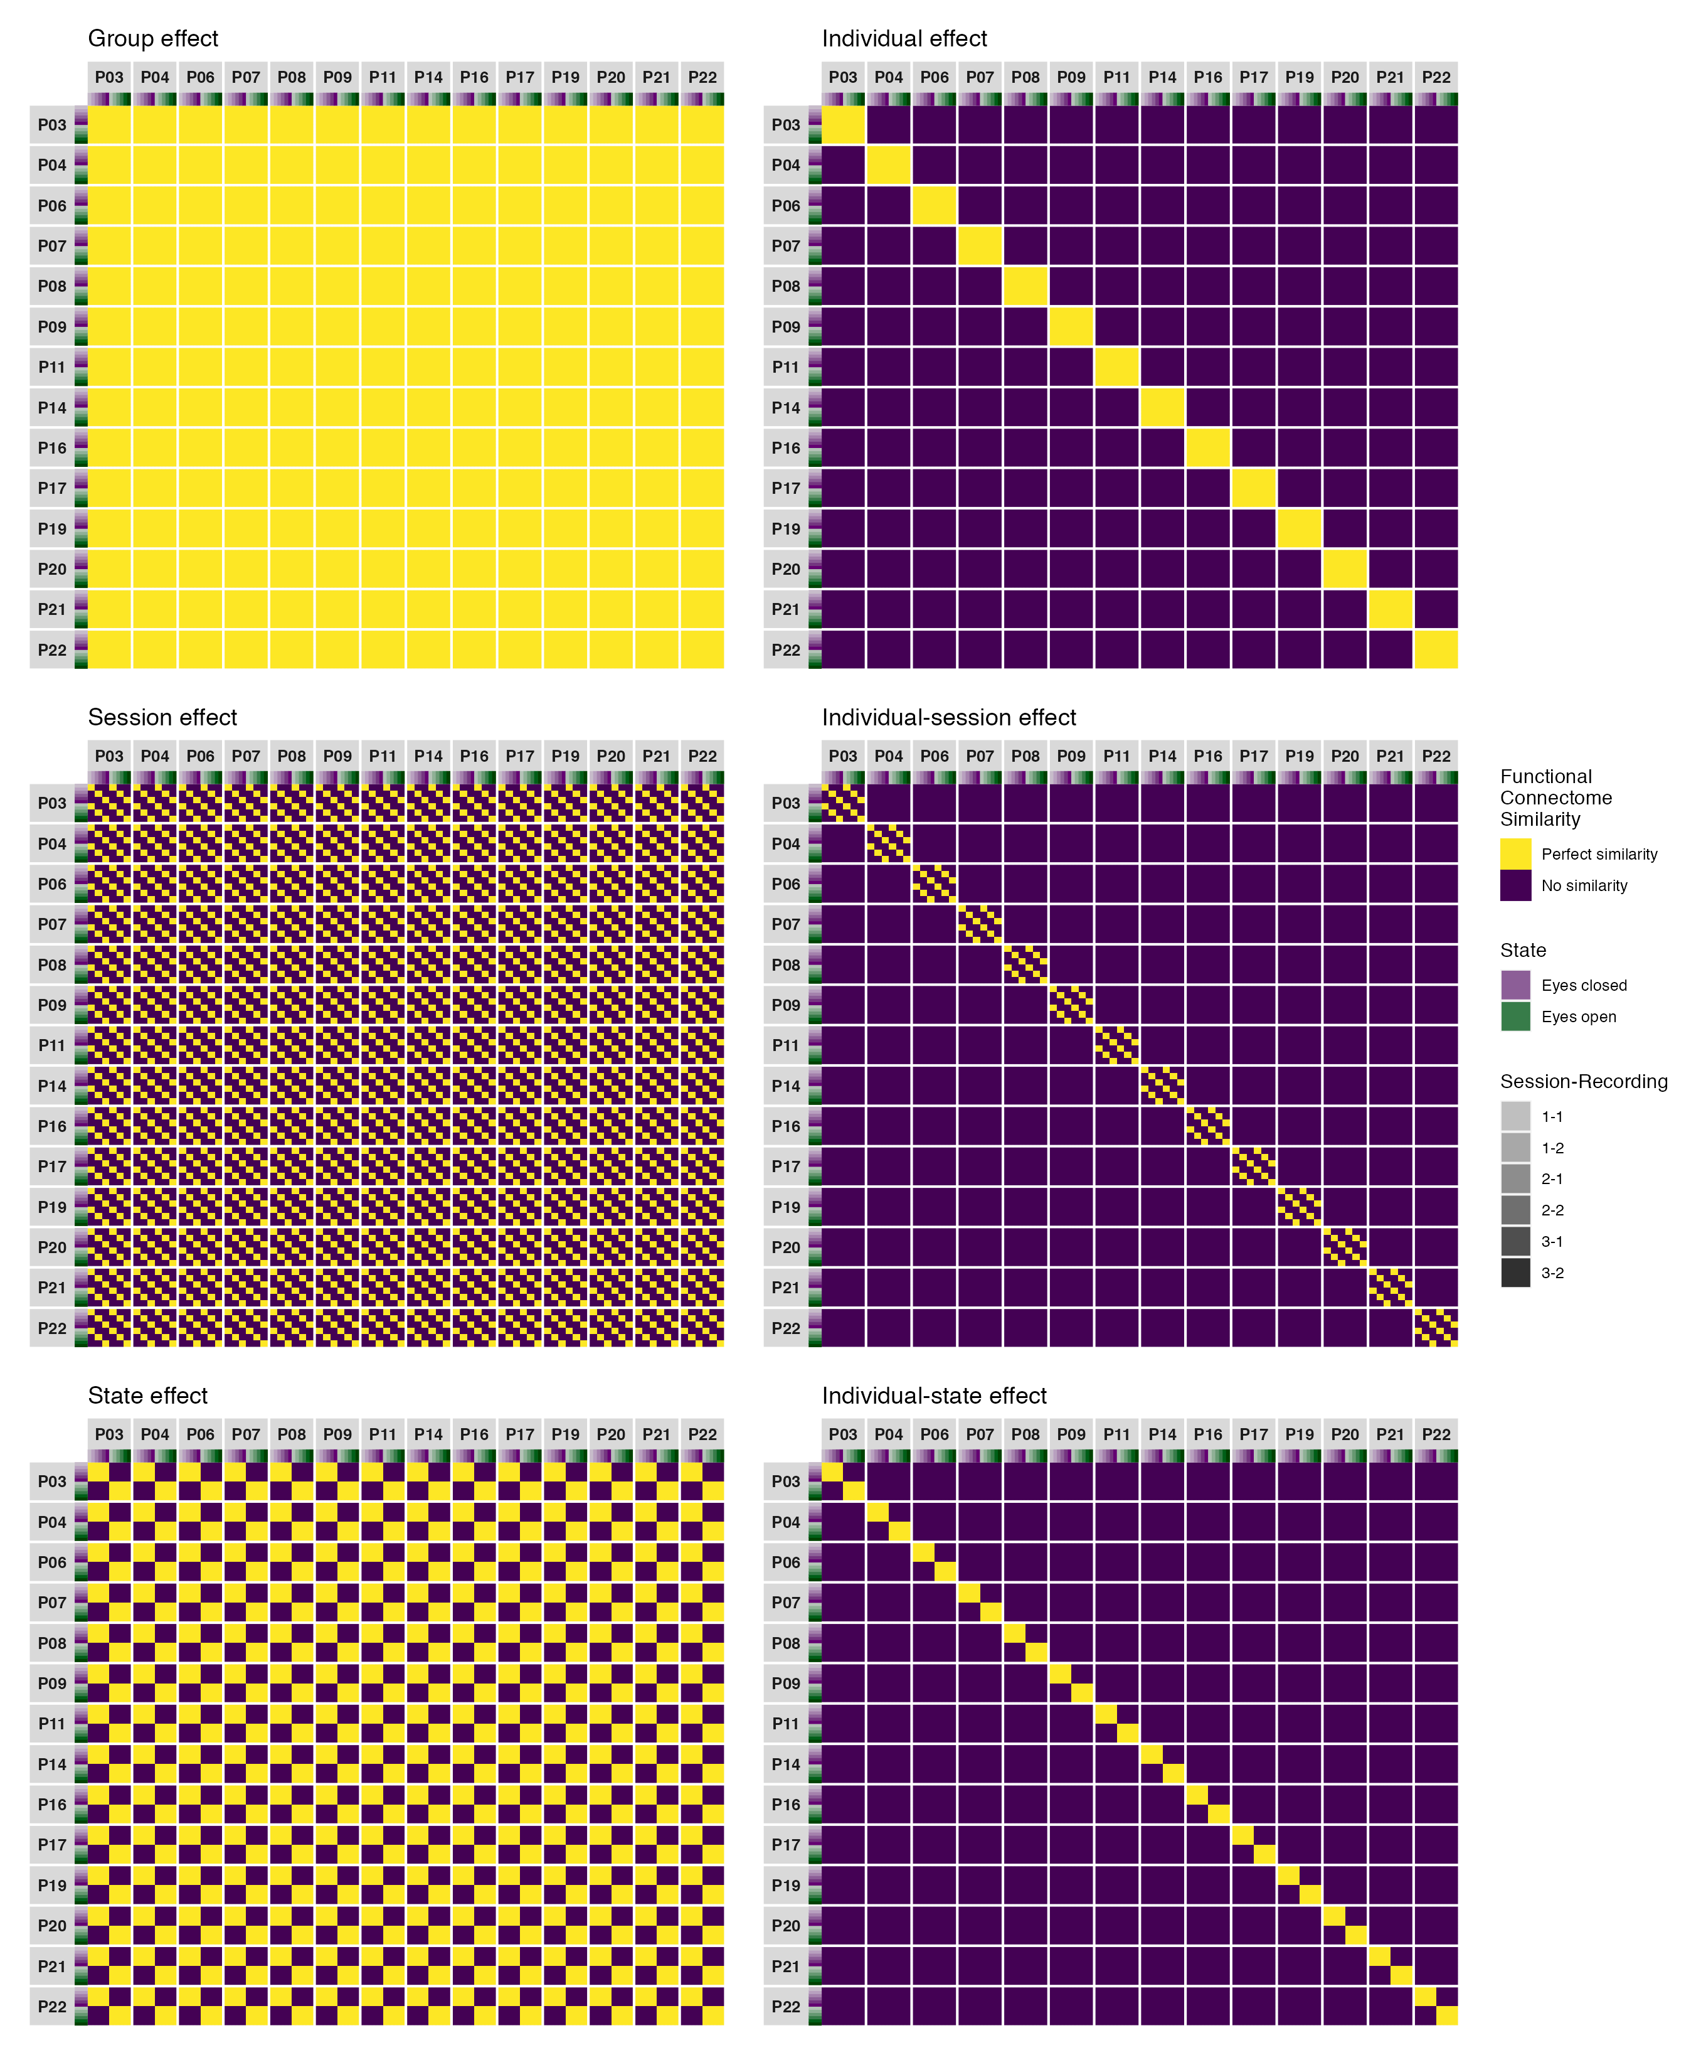

*Figure* *1.*  Similarity matrices depicting six archetypal outcomes of network similarity that could occur if brain activity is common across individuals (group, session, or state effects) or unique within individuals (individual, individual-session, or individual-state effects).

It is likely that the real data will be representative of more than one of these archetypes. Based on the prior work discussed above, we expect to find effects consistent with functional connectomes that are more similar within than between individuals, with smaller variations in similarity related to session or state—consistent with the idea that functional networks are stable and trait-like with equal amounts of common and unique variance between individuals. To examine our hypotheses we contrast the magnitude of each of these effects and examine how they are distributed across different timescales using EEG functional connectivity analysis and measures of network similarity.

# Methods

## Data

In this study, we used EEG data previously collected by our lab as part of a larger study. The larger study involved the collection of EEG recordings during resting state (eyes open and eyes closed) and during a lexical decision task (Meyer & Schvaneveldt, 1971) across three repeated measures sessions. The data collected during the lexical decision task is described in detail by Cnudde et al. (2021) and is available at <https://osf.io/da478/>. Here we only use the EEG recordings collected during resting state, which has not been previously described or made publicly available. All participants provided written informed consent before taking part in the study and were provided with monetary compensation for their participation. Ethics approval was received from the Conjoint Faculties Research Ethics Board of the University of Calgary.

### Participants.

Twenty-one healthy adults (10 males, 11 females) whose ages ranged from 20 to 28 years (M = 23.90, SD = 2.86) and whose years of education ranged from 13 to 24 years (M = 17.48, SD = 2.75) participated in the study. All participants were right handed, spoke English as a first language, and had normal or corrected-to-normal vision. Exclusion criteria included a history of neurological disease or disorder, mental illness, head trauma, alcoholism or drug abuse, or use of psychotropic medications in the last two years preceding data collection. We excluded EEG data for analysis from four participants because they did not participate in the final session, and three participants because they had one or more recordings with excessive noise. The final sample used for analysis consisted of fourteen participants (7 males, 7 females) whose ages ranged from 20 to 28 years (M = 23.86, SD = 3.13) and whose years of education ranged from 13 to 23 years (M = 17.21, SD = 2.72).

### Electrophysiological Data Acquisition.

Electrophysiological data acquisition was completed in a dimly lit, radio frequency shielded, and sound attenuated chamber. During each session, an EasyCap with 64 gel-based active electrodes positioned following the 10-10 system (Chatrian, Lettich, & Nelson, 1985, 1988) was used to continuously record electrophysiological activity at the scalp (Brain Products GmbH, Gilching, Germany). Channel Cz was used as the reference electrode. A Brain Vision Solutions actiCHamp amplifier was used to amplify microvolt signals from the electrodes and transform them into digital format for storage and analysis (Brain Products GmbH, Gilching, Germany). All data were sampled at 500 Hz, and band limited with a built-in 0.05-100 Hz band-pass filter. All electrode impedances were below 17 kW at the start of recording. EEG recording lasted for a total of 80 minutes. We first recorded five minutes of eyes open and five minutes of eyes closed resting state date, with the order of these conditions counter-balanced across participants. This was followed by approximately 60 minutes of task state data recorded during performance of a lexical decision task (for a detailed description, see Cnudde et al., 2021). Finally, eyes open and eyes closed resting state data were recorded for five minutes each, again counter-balanced across participants.

Across all three sessions, we collected a total of 30 minutes eyes open resting state data (over 6 recordings) and 30 minutes eyes closed resting state data (over 6 recordings) from each participant. The time between the first and second session ranged from 8 to 13 days (M = 9.57, SD = 1.55), and between the second and third session ranged from 91 to 101 days (M = 94.29, SD = 3.17).

## Software and computational reproducibility

All computational steps were done using the open source programming language R (version 4.1.1, <https://www.R-project.org/>; R Core Team, 2021). We maintained a reproducible workflow for the entire pipeline—from data cleaning to reporting—using the targets package (Landau, 2022), and managed R and Python dependencies using the renv package (Ushey, 2022). All EEG preprocessing and functional connectivity analysis was done using the open source Python package MNE-Python (version 2.2.0, <https://doi.org/10.5281/zenodo.4338426>; Gramfort et al., 2013), which was called from R using the reticulate package (Ushey, Allaire, & Tang, 2022). We estimated the RV coefficient using the FactoMineR package (Husson, Josse, Le, & Mazet, 2020), and fit the mixed beta regression and contrasts using the glmmTMB (Magnusson et al., 2021) and emmeans (Lenth, 2022) packages, respectively. The DHARMa (Hartig, 2022) and performance (Lüdecke et al., 2022) packages were used for model diagnostics. All data visualization was done with a combination of the ggplot2 (Wickham et al., 2021), ggdist (Kay, 2022), ggh4x (van den Brand, 2021), ggnewscale (Campitelli, 2022), and patchwork (Pedersen, 2020) packages. Other computations were done using the tidyverse (Wickham, 2021) suite of packages. Finally, this manuscript itself was written in R Markdown (Allaire et al., 2022) using the papaja package’s APA template (Aust & Barth, 2022), and all reported numbers and figures were printed using inline code to ensure their accuracy. A complete record of the R environment and packages used in this study can be found in Tables 1 and 2 in the appendix.

## EEG preprocessing

Raw EEG data was preprocessed to remove noise and non-neural artifacts from the data using the following steps. First, following recommendations by Widmann, Schröger, and Maess (2015), a two-pass forward and reverse, zero-phase, non-causal band-pass finite impulse response filter was used to remove slow drift potentials at infraslow frequencies less than 0.10 Hz, line noise at 60.00 Hz, and irrelevant noise fluctuations greater than 60.00 Hz (de Cheveigné & Nelken, 2019; Widmann et al., 2015). The finite impulse response filter used a Hamming window with 0.0194 passband ripple and 53 dB stopband attenuation. The lower passband edge and transition bandwidth were set at 0.10 Hz (-12 dB cutoff frequency: 0.05 Hz), and the upper passband edge and transition bandwidth were set at 50.00 Hz (-12 dB cutoff frequency: 56.25 Hz). The filter length was 16501 samples (33.002 seconds). These filter parameters were selected after exploring the difference between raw and filtered signals and verifying that the selected filter parameters improved signal quality over alternative filter parameters or the raw signal (Widmann et al., 2015). Second, the data was downsampled from 500 to 200 Hz in order to reduce the size of the data and speed up computations operating on the data. Third, data was rereferenced to the common average reference in order to reduce spatial biases in the signal amplitude of channels caused by their distance to the original reference electrode (Nunez & Srinivasan, 2006). Fourth, bad channels and segments were manually marked and removed to prepare the data for ICA decomposition. Channels were marked as bad if they contained excessive noise or drift for a significant portion of the recording. Bad channels were marked in 26.19% of recordings, ranging from 1 to 7 bad channels marked per recording with a mode of 1. Segments were marked as bad if they contained excessive noise or drift that (1) could interfere with fitting the ICA decomposition due to the amount of variance their component would capture, or (2) was unlikely to be repaired by ICA decomposition. Bad segments were marked in 94.05% of the recordings, ranging from 0 to 11 bad segments marked per recording with a mode of 1. The total duration of bad segments per recording across the entire sample ranged from 0.97 to 124.81 seconds long (M = 17.89, SD = 18.30). Fifth, ICA decomposition fitted using the Picard algorithm (Ablin, Cardoso, & Gramfort, 2017, 2018) was performed to remove components carrying muscle artifacts or ocular artifacts (eye blinks, saccades, or horizontal eye movements) from the data. Components carrying artifacts were manually selected and then removed. Finally, bad channels were interpolated using spherical splines (Perrin, Pernier, Bertrand, & Echallier, 1989) and put back into the data.

After artifact rejection, the continuous data was divided into epochs and filtered to prepare for functional connectivity analysis. This was a three step process. First, the epochs with an 8 second duration were created at 5 second intervals such that an epoch occurred from 0-8 seconds, 5-13 seconds, 10-18 seconds, and so forth, until the end of the recording. Epochs that contained a bad segment were removed. Second, the epoched data was filtered into five frequency bands—delta ($δ$, 1-4 Hz), theta ($θ$, 4-8 Hz), alpha ($α$, 8-13 Hz), beta ($β$, 13-30 Hz), and gamma ($γ$, 30-50 Hz)—using a two-pass forward and reverse, zero-phase, non-causal band-pass finite impulse response filter. Third, epochs were cropped to a 5 second duration starting 1 second into each epoch such that an epoch then occurred from 1-6 seconds, 6-11 seconds, 11-16 seconds, and so forth.

Filtering the data into five frequency bands allowed us to investigate whether the organization of functional networks between and within individuals was dependent or invariant of timescale (frequency band) (Mostame & Sadaghiani, 2021). However, filtering epoched data creates edge artifacts at the start and end of each epoch that distort the true signal. Creating longer epochs in the first step provided padding around the edges of each epoch that could be cropped in the third step to remove these edge artifacts; and overlapping epochs in the first step made it possible for the cropped epochs in the third step to be non-overlapping and contiguous with reference to the continuous data, preserving the true signal across the length of the recording. The 5 second duration was selected based on the minimum epoch length required to get reliable phase coupling estimates in the delta band.

## Analyses

### Functional Connectivity.

Functional connectivity was estimated between all pairs of EEG channels using the phase lag index (PLI; Stam, Nolte, & Daffertshofer, 2007) and the orthogonalized amplitude envelope correlation (AEC; Hipp, Hawellek, Corbetta, Siegel, & Engel, 2012), which measure phase coupling and amplitude coupling, respectively. Both the phase lag index and the orthogonalized amplitude envelope correlation account for the effects of field spread and volume conduction, reducing the possibility of spurious coupling between channels from influencing our functional connectivity estimates (Bastos & Schoffelen, 2016). The resulting functional connectivity estimates from each recording were collected into twelve symmetrical $64×64$ matrices called *functional connectomes* per frequency band and measure, which reflected electrophysiological cortical functional networks derived from averaged phase or amplitude coupling between each pair of channels. These functional connectomes were the basic unit of observation for subsequent analyses.

#### Phase coupling.

The average amount of phase coupling between pairs of sensors was estimated in each recording using the phase lag index (PLI; Stam et al., 2007). The phase lag index estimates the asymmetry of the distribution of phase angle differences between two signals $x$ and $y$ (Stam et al., 2007; Vinck, Oostenveld, van Wingerden, Battaglia, & Pennartz, 2011), given by:

$$PLI\left(x,y\right)=\frac{1}{n}\sum_{f=1}^{n}{\left|\frac{1}{N}\sum_{i=1}^{N}{\text{sign}}\left(\text{imag}\left(S_{xyfi}\right)\right)\right|},$$

where $n$ is the number of frequency bins in each frequency band, $N$ is the number of epochs, $\text{sign}\left(⋅\right)$ is the signum operator, $\text{imag}\left(⋅\right)$ is the imaginary operator, and $S_{xyi}$ is the complex-valued cross spectral density between two sensors $x$ and $y$ at the individual frequency bins $f$ in the $i$ th epoch, from which we extract the phase angle differences at each frequency bin.

We estimated the cross spectral density between two signals $x$ and $y$ using multitaper spectral estimation (Babadi & Brown, 2014; Thomson, 1982) with digital prolate spheroidal sequence (DPSS) (Slepian & Pollak, 1961) windows. Seven tapers were used for each frequency band. The individual frequency bins used for each frequency band was determined by calculating the Discrete Fourier Transform sample frequencies for a 1001 sample window (corresponding to a 5 second epoch) and a sample space of 0.005 (the inverse of the 200 Hz sampling rate). This resulted in 501 frequency bins spaced at roughly 0.2 Hz intervals between zero and 100 Hz. Then for each frequency band we simply selected the frequency bins that were equal to or between the minimum and maximum frequencies of each frequency band.

The phase lag index takes values between 0 and 1. A value of 0 indicates either no phase coupling or phase coupling with a phase angle difference centred around 0 or 180 degrees, and a value of 1 indicates perfect phase coupling with a consistent nonzero phase angle difference. By only considering consistent nonzero phase angle differences as indicators of phase coupling between two sensors, the phase lag index ignores phase coupling that could be explained by volume conduction from a single common source (at the cost of also ignoring non-spurious zero lag coupling), making it a sound measure of the interactions between different underlying neural sources (Stam et al., 2007).

#### Amplitude coupling.

The average amount of amplitude coupling between pairs of sensors was estimated in each recording using the orthogonalized amplitude envelope correlation (AEC; Hipp et al., 2012). The orthogonalized amplitude envelope correlation estimates the absolute Pearson correlation coefficient of the amplitude envelopes between two orthogonalized complex-valued analytic signals $x$ and $y$ (Hipp et al., 2012), given by:

$$AEC\left(x,y\right)=\left|\frac{1}{N}\sum_{i=1}^{N}{\frac{\sum_{t=1}^{n}{\left(x_{it}-{\overset{‾}{x}}_{i}\right)}\left(y_{it}-{\overset{‾}{y}}_{i}\right)}{\sqrt{\sum_{t=1}^{n}{{\left(x_{it}-{\overset{‾}{x}}_{i}\right)}^{2}}\sum_{t=1}^{n}{{\left(y_{it}-{\overset{‾}{y}}_{i}\right)}^{2}}}}}\right|,$$

where $N$ is the number of epochs, $n$ is the number of samples in each epoch, $x_{ij}$ and $y_{ij}$ are the individual sample points $t$ of the amplitude envelopes in the $i$ th epoch, and ${\overset{‾}{x}}_{j}$ and ${\overset{‾}{y}}_{j}$ are the sample means of the amplitude envelopes in the $i$ th epoch.

We extracted the analytic signal from each channel’s time-course using the Hilbert transform (Stam et al., 2007). Following this, the complex-valued analytic signals $X\left(a,b\right)$ and $Y\left(a,b\right)$ for each pair of channels were orthogonalized by removing signal components that shared the same phase between the two signals (Hipp et al., 2012), given by:

$$X_{⊥Y}\left(a,b\right)=\text{Im}\left(X\left(a,b\right)\frac{Y{\left(a,b\right)}^{*}}{|Y\left(a,b\right)|}\right),$$

where $Y{\left(a,b\right)}^{*}$ is the complex conjugate of $X\left(a,b\right)$. Similarly to the phase lag index, the orthogonalization procedure used here allowed us to ignore parts of the signal that can be explained by volume conduction from a single common source, making the subsequent amplitude envelope correlations a sound measure of the interactions between different underlying neural sources (Hipp et al., 2012). After orthogonalization, the amplitude envelopes of the two analytic signals were computed by taking the absolute value of each signal, then the amplitude envelope correlation between them was estimated. We computed amplitude envelope correlations for both directions of the orthogonalization ( $X$ to $Y$, and $Y$ to $X$), then averaged the values to get the final amplitude envelope correlation estimate for each pair.

The amplitude envelope correlation takes values between 0 and 1. A value of 0 indicates no amplitude coupling between the orthogonalized signals, and a value of 1 indicates perfect amplitude coupling with a consistent amplitude envelope correlation between the orthogonalized signals.

#### Interpreting functional connectivity.

We use connectivity profile matrices (Demuru et al., 2017) to compactly display the phase and amplitude coupling functional connectome from each recording. These plots serve as a supplement to our similarity analyses, providing a broad idea of what aspects of functional connectivity are being summarized by a given similarity estimate. Each row shows the vectorized lower-triangle of the phase or amplitude coupling functional connectome from a given recording (i.e., all unique pairs in the connectome), and each column represents a pair of sensors. The strength of coupling between any pair of sensors corresponds to their phase lag index or amplitude envelope correlation estimate and is represented by the colour of that cell in the matrix, with darker colours representing less coupling and brighter colours representing more coupling.

### Functional connectome similarity.

The similarity of phase- and amplitude-based functional connectomes was next quantified by estimating the RV coefficient (Robert & Escoufier, 1976) between all pairs of functional connectomes from a given individual, session, and state within each frequency band (14,028 pairs total). The RV coefficient is a multivariate measure of the linear relationship between two positive semi-definite matrices $X$ and $Y$ that takes values between 0 (no linear relationship) and 1 (perfect linear relationship) (Abdi, Hervé, 2007; Escoufier, 1973; Josse & Holmes, 2016; Robert & Escoufier, 1976), given by:

$$RV\left(X,Y\right)=\frac{\text{trace}\left(ST\right)}{\sqrt{\text{trace}\left(SS\right)×\text{trace}\left(TT\right)}},$$

where $S={XX}^{T}$ and $T={YY}^{T}$. The RV coefficient can be thought of as a generalization of the squared Pearson correlation coefficient between two variables to the case of two sets of variables, where two sets of variables are correlated if the relative position (in Hilbert space) of the observations in one set is similar to the relative position of the observations in the other set (Josse & Holmes, 2016; Mayer, Lorent, & Horgan, 2011). However, as can be seen in the equation above, unlike the Pearson correlation coefficient, the mean of the observations in a set is not subtracted from its observations when estimating the RV coefficient (Abdi, Hervé, 2007). The RV coefficient is sensitive to both the overall extent and the pattern of coupling, making it a viable measure for studying network variants.

#### Interpreting functional connectome similarities.

We use similarity matrices to examine the similarities of functional connectomes between and within individuals, sessions, and states. When interpreting a similarity matrix, the two most important features are the *strength* and *pattern* of similarities. The strength of similarity between any pair of functional connectomes corresponds to their RV coefficient estimate and is represented by the colour of that cell in the matrix, with darker colours representing less similarity and brighter colours representing more similarity. To interpret the pattern of similarities we first need to consider the ordering of functional connectomes in the matrix. The boxes on the diagonal show within-participant similarities between all twelve functional connectomes from a given participant, the boxes on the off-diagonal show between-participant functional connectome similarities. With this organization in mind, we can examine the similarity matrix for visually obvious patterns of low and high similarity, such as those depicted in Figure 1 in the introduction.

### Group-level functional connectome similarity contrasts.

We used a mixed beta regression to model how functional connectome similarity varied between and within individuals, sessions, and states at the group-level for each frequency band (for an accessible overview of mixed beta regression, see Douma & Weedon, 2019; Heiss, 2021). The unit of observation was the pair of functional connectomes used for a given similarity estimate. The response variable was the RV coefficient estimated for each pair, which was modelled with a beta distribution and related to the predictors with the logit link function following the parameterization of Cribari-Neto and Zeileis (2010) and Ferrari and Cribari-Neto (2004). The predictors were binary indicators (where $0=\text{No}$ and $1=\text{Yes}$) for whether a pair was within participant, within session, or within state, and their interactions. Because the RV coefficient estimates are based on the similarity of pairs of functional connectomes, we included a random intercept for both the $X$ and $Y$ connectome that each observation came from to account for statistical dependencies between observations that had a connectome in common. All random effects were assumed to be normally distributed (Brooks et al., 2017).

We also originally planned to include a random intercept for the participant pair to account for the repeated observation of the same participant pairs, however including this term led to convergence problems for several of our models where the estimate for the variance of this parameter was zero. Although in principle participant pair should have been included in the statistical model as a random intercept to account for the repeated measures design, we decided not to include this parameter for pragmatic reasons so all our models would converge. The effect of not including participant pair was negligible for point estimates, which were similar or equivalent between models where it was and was not included; but was noticeable for interval estimates, which were generally wider by a factor of two to four when it was included compared to when it was not included. This difference did not meaningfully change the conclusions drawn from our results, however.

The fit of the model was assessed using the following diagnostics: Posterior predictive checks—wherein we simulated replicated data under the fitted model and compared these to the observed data—were used to check for systematic differences between the fitted model and observed data (Gelman et al., 2013; Gelman & Hill, 2006; Gelman, Hill, & Vehtari, 2020). Randomized quantile residuals plotted against uniform distribution quantiles were used to check for signs of model misspecification (Dunn & Smyth, 1996; Hartig & Lohse, 2022). Quantiles of the random effects plotted against standard normal distribution quantiles were used to check if the random effects were normally distributed; however, generalized linear mixed effects models have a large degree of robustness against misspecifying the shape of the random effects distribution (see McCulloch & Neuhaus, 2011). Variance Inflation Factors were used to check for multicollinearity between the predictors (Fox & Monette, 1992; Marcoulides & Raykov, 2019; O’brien, 2007), where a value of less than five as indicated low multicollinearity between the predictors, values between five and ten moderate, and values greater than ten high and not tolerable (James, Witten, Hastie, & Tibshirani, 2021).

After fitting the model we constructed a reference grid using estimated marginal means (Lenth et al., 2022; Searle, Speed, & Milliken, 1980), which were back-transformed to the response scale (0-1) for interpretability. The estimated marginal means were then used to estimate the difference in functional connectome similarity within and between participants using pairwise contrasts. Differences were estimated for (1) the overall difference in similarity within and between participants, which we term the *main effect*; (2) the difference in similarity within and between participants for each level of one predictor (e.g., within session similarity) while averaging over levels of the other predictor (e.g., within and between state similarity); (3) the difference in similarity within and between participants for the unique combinations within and between session and state. For any of these contrasts: A difference of zero indicated equal amounts of functional connectome similarity within and between participants, a positive difference indicated more similarity within than between participants, and a negative difference indicated more similarity between than within participants.

#### Interpreting group-level contrasts.

We use interval plots to report the group-level contrasts estimating the difference in functional connectome similarity within and between participants at various levels of the session and state predictors. To interpret these contrasts, we report compatibility intervals (CIs), which are equivalent to classical confidence intervals (Amrhein & Greenland, 2022). An $x\%$ compatibility interval shows the effect sizes most compatible with our data, given the correctness of the set of statistical assumptions used to compute the interval, which we call the *background model* (see Amrhein & Greenland, 2022). As discussed by Amrhein, Greenland, and McShane (2019), there are two important points to keep in mind when interpreting compatibility intervals. First, although interval shows the values most compatible with our data, it does not mean values outside the interval are incompatible; they are merely less compatible. Second, the point estimate and values near it are more compatible with our data than values near the limits of the interval; we use both 95% and 66% compatibility intervals in our plots to highlight this. Additionally, given that the correctness of all assumptions used to compute our estimates was questionable (e.g., we knowingly misspecified the random effects of the mixed beta regressions), we emphasize that our estimates likely understate uncertainty about the effect sizes most compatible with our data, and should not be taken as showing some general truth. Based on the results of Gratton et al. (2018), we might consider contrasts showing that functional connectomes were approximately 0.2 points (on the response scale) more similar within participants than between participants to correspond to what has been found with shorter fMRI scanning times (depending on the task, anywhere from 5 to 15 minutes), and approximately 0.3 points more similar to correspond to what has been found with longer scanning times (depending on the task, anywhere from 25 to 75 minutes),[1] keeping in mind that finding equivalent effect sizes would be surprising, given the differences in measurement, design, and analysis between our studies. As a lower bound, we considered differences of approximately 0.1 points to be a small but meaningful effect size, as differences of this size might still provide weak evidence for the presence of network variants.

### Individual-level functional connectome similarity contrasts.

To explore how well the group-level model and contrasts represented individual differences in our sample, we also fit a mixed beta regression for each participant, following the same parameterizations as the group-level model. These individual-level models were followed-up using the same pairwise contrasts as in the group-level model, and comparisons between the group-level and individual-level contrasts were done visually.

#### Interpreting individual-level contrasts.

We use ridge plots to report the individual-level contrasts estimating the difference in functional connectome similarity within and between participants at various levels of the session and state predictors. To interpret these contrasts, we report 95% compatibility distributions, which are equivalent to classical confidence distributions (Schweder & Hjort, 2016; Xie & Singh, 2013). Like with a compatibility interval, a 95% compatibility distribution shows the effect sizes most compatible with our data, given the background model, and is a sample-dependent distribution representing compatibility intervals of all levels for a parameter (Xie & Singh, 2013). We used scaled and shifted $t$ distributions as the sampling distribution for the individual-level contrasts, using the point estimate, standard error, and degrees of freedom as parameters for the distribution. The peak of the distribution corresponds to the point estimate, and changes in the density of the distribution correspond to differences in compatibility values have with our data.

# Results

## Overview

The results are separated into five sections, one for each frequency band, covering first the similarities of phase coupling functional connectomes, then amplitude coupling functional connectomes. In each section, we present the results in four plots: (1) a connectivity profile matrix showing the vectorized lower-triangle of the phase or amplitude coupling functional connectome from each recording; (2) a similarity matrix showing the RV coefficient estimates between all pairs of phase or amplitude coupling functional connectomes; (3) an interval plot showing the group-level contrasts estimating the difference in functional connectome similarity within and between participants at various levels of the session and state predictors; and (4) ridge plots showing the results for the individual-level contrasts estimating the difference in functional connectome similarity within and between participants at various levels of the session and state predictors. As a reminder, we considered contrasts showing that functional connectomes were approximately 0.2 and 0.3 points (on the response scale) more similar within participants than between participants to correspond to what has been found with shorter and longer fMRI scanning times, respectively. As a lower bound, we considered differences of approximately 0.1 points to be a small but meaningful effect size, as differences of this size might still provide weak evidence for the presence of network variants. Further descriptions of how each of these plots can be interpreted can be found in the methods section.

## Delta band

### Phase coupling similarities.

Figure 2 shows the connectivity profile matrix, similarity matrix, interval, and ridge plots for phase coupling functional connectome similarities in the delta band. Across all functional connectomes and sensor pairs, the phase lag index ranged from 0.02 to 0.87 (M = 0.16, SD = 0.07; Figure 2A). There was a visually obvious group effect, with high similarity between functional connectomes regardless of participant, session, or state (Figure 2B). This was supported by the group-level contrasts, which showed that although functional connectomes were more similar within participants than between participants at all levels of the session and state predictors, the effect sizes most compatible with our data, given the background model, were at most very small and not meaningful (Figure 2C). On average, differences in similarity were largest when contrasting functional connectomes from the same session and state ($Δ$ RV = 0.026, 95% CI = [0.021, 0.031]), and smallest when contrasting functional connectomes from different sessions and states ($Δ$ RV = 0.003, 95% CI = [0.000, 0.006]), with an overall difference of $Δ$ RV = 0.013, 95% CI = [0.011, 0.016]. Moreover, the individual-level contrasts also made it clear that the slightly higher within participant similarity at the group-level should not be overinterpreted, given that the data did not resolve whether the most compatible effect sizes were positive or negative for nearly all participants at most levels of the session and state predictors (Figure 2D).

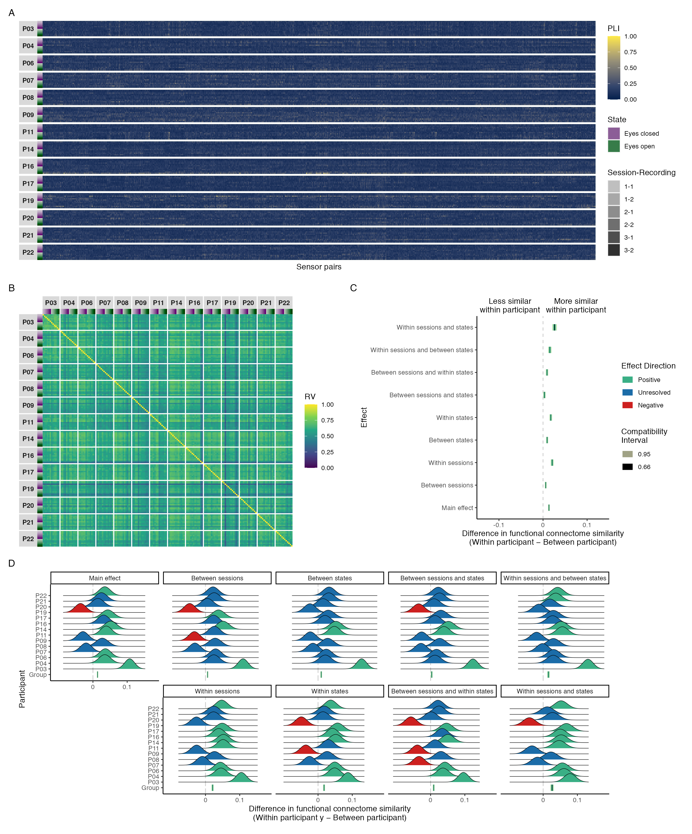

*Figure* *2.*  Connectivity profile matrix (A), similarity matrix (B), interval plot (C), and ridge plots (D) for phase coupling functional connectome similarities in the delta band.

### Amplitude-coupling similarities.

Figure 3 shows the connectivity profile matrix, similarity matrix, interval, and ridge plots for amplitude coupling functional connectome similarities in the delta band. Across all functional connectomes and sensor pairs, the orthogonalized amplitude envelope correlation ranged from 0.00 to 0.49 (M = 0.04, SD = 0.03; Figure 3A). There was a visually obvious group effect, with near-perfect similarity between functional connectomes regardless of participant, session, or state (Figure 3B). This was supported by the group-level contrasts, which showed that the differences in functional connectome similarity within and between individuals most compatible with our data, given the background model, were practically nil at all levels of the session and state predictors, with an overall difference of $Δ$ RV = 0.001, 95% CI = [0.001, 0.001] (Figure 3C).

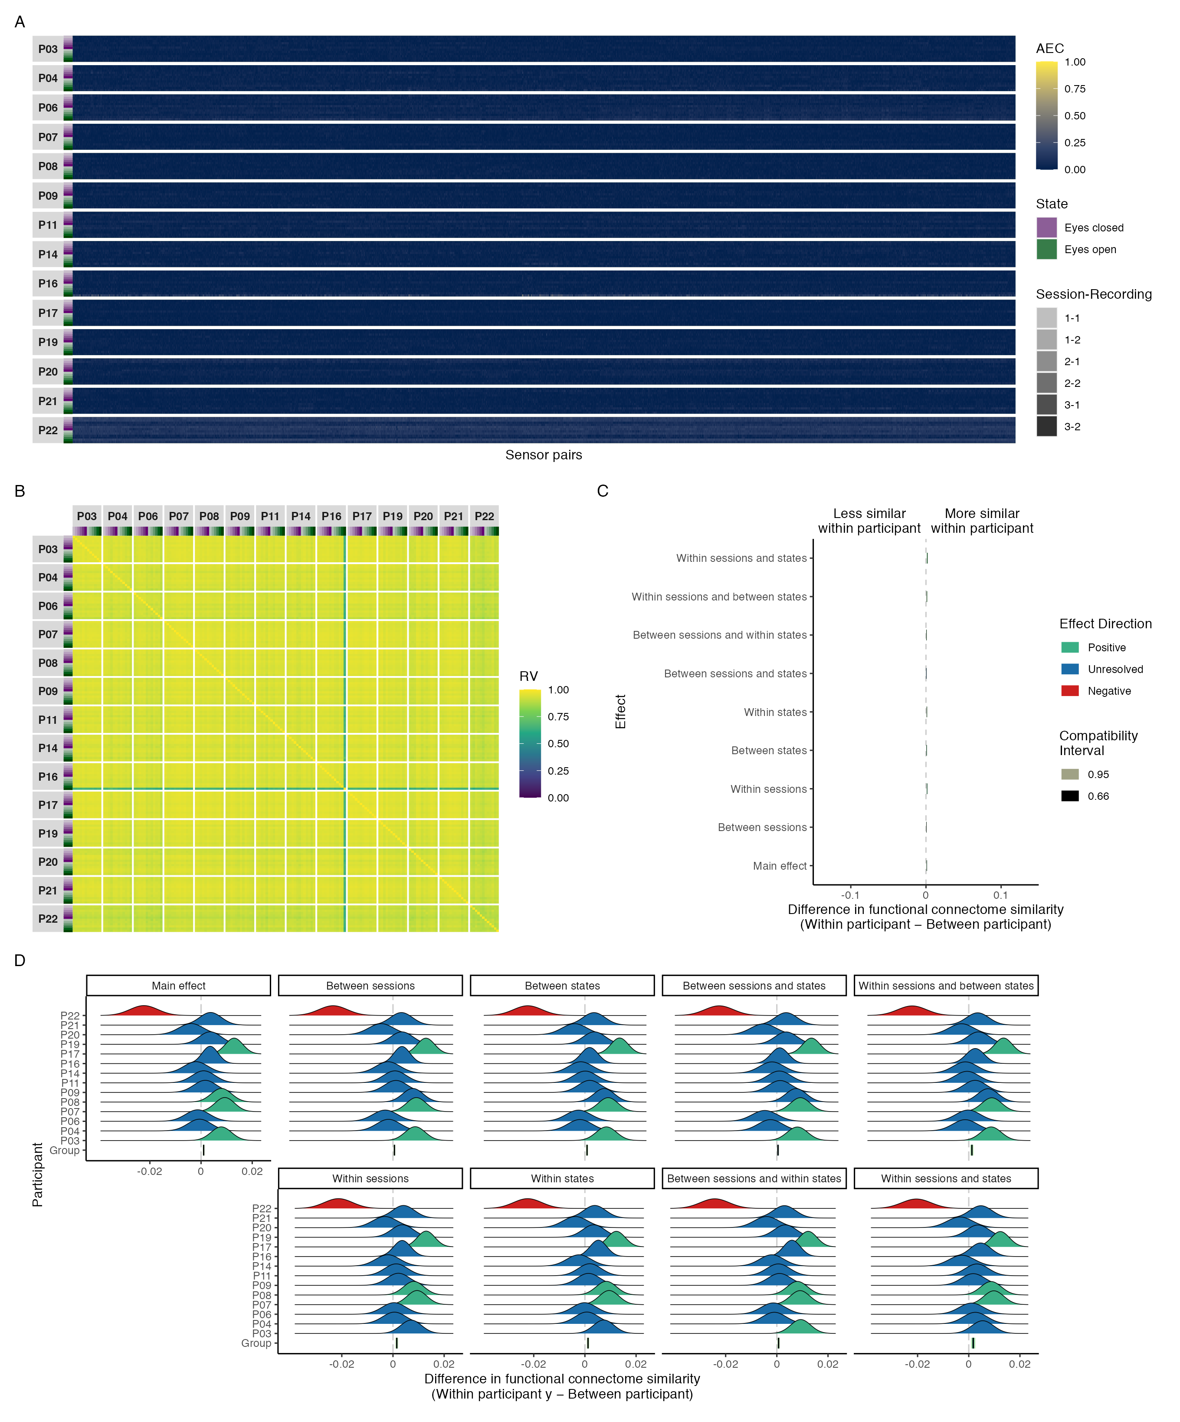

*Figure* *3.*  Connectivity profile matrix (A), similarity matrix (B), interval plot (C), and ridge plots (D) for amplitude coupling functional connectome similarities in the delta band.

## Theta band

### Phase-coupling similarities.

Figure 4 shows the connectivity profile matrix, similarity matrix, interval, and ridge plots for phase coupling functional connectome similarities in the theta band. Across all functional connectomes and sensor pairs, the phase lag index ranged from 0.03 to 0.97 (M = 0.16, SD = 0.07; Figure 4A). There was a visually obvious group effect, with high similarity between functional connectomes regardless of participant, session, or state (Figure 4B)—but with slightly more variability within and between participants than we found with phase coupling functional connectomes in the delta band. This was reflected in the group-level contrasts, which showed that functional connectomes were somewhat more similar within participants than between participants at all levels of the session and state predictors, relative to the delta band; however, the effect sizes most compatible with our data, given the background model, were still at most small and not meaningful (Figure 4C). On average, differences in similarity were largest when contrasting functional connectomes from the same session and state ($Δ$ RV = 0.044, 95% CI = [0.037, 0.051]), and smallest when contrasting functional connectomes from different sessions and states ($Δ$ RV = 0.019, 95% CI = [0.015, 0.022]), with an overall difference of $Δ$ RV = 0.029, 95% CI = [0.026, 0.031]. Again the individual-level contrasts made it clear that the higher within participant similarity at the group-level should not be overinterpreted, given that the data did not resolve whether the most compatible effect sizes were positive or negative for roughly half the participants at most levels of the session and state predictors; however, roughly one-third of the participants did have effect sizes that were consistently positive and reasonably compatible with values that were small and meaningful (4D).

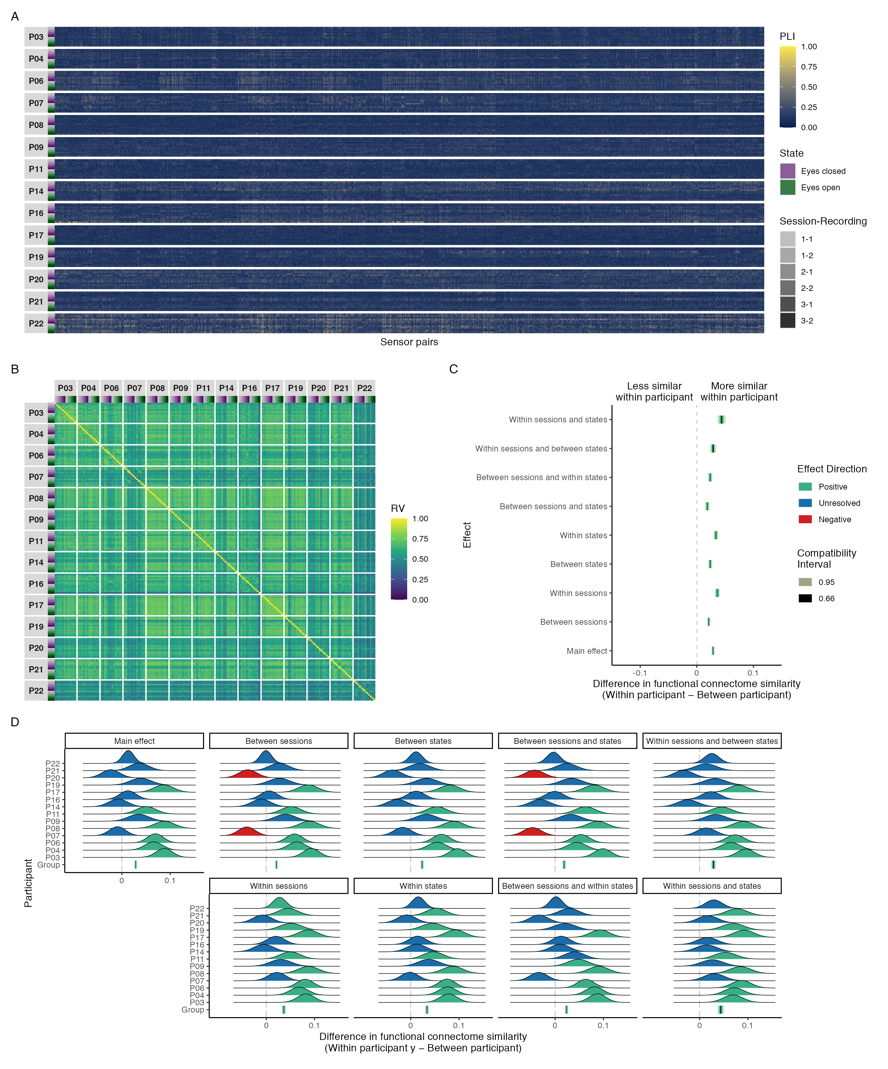

*Figure* *4.*  Connectivity profile matrix (A), similarity matrix (B), interval plot (C), and ridge plots (D) for phase coupling functional connectome similarities in the theta band.

### Amplitude-coupling similarities.

Figure 5 shows the connectivity profile matrix, similarity matrix, interval, and ridge plots for amplitude coupling functional connectome similarities in the theta band. Across all functional connectomes and sensor pairs, the orthogonalized amplitude envelope correlation ranged from 0.00 to 0.68 (M = 0.07, SD = 0.06; Figure 5A). Here too there was slightly more variability within and between participants than we found in the delta band, but there was still a visually obvious group effect, with near-perfect similarity between functional connectomes regardless of participant, session, or state (Figure 5B). This was supported by the group-level contrasts, which showed that the differences in functional connectome similarity within and between individuals most compatible with our data, given the background model, were practically nil at all levels of the session and state predictors, with an overall difference of $Δ$ RV = 0.008, 95% CI = [0.007, 0.009] (Figure 5C).

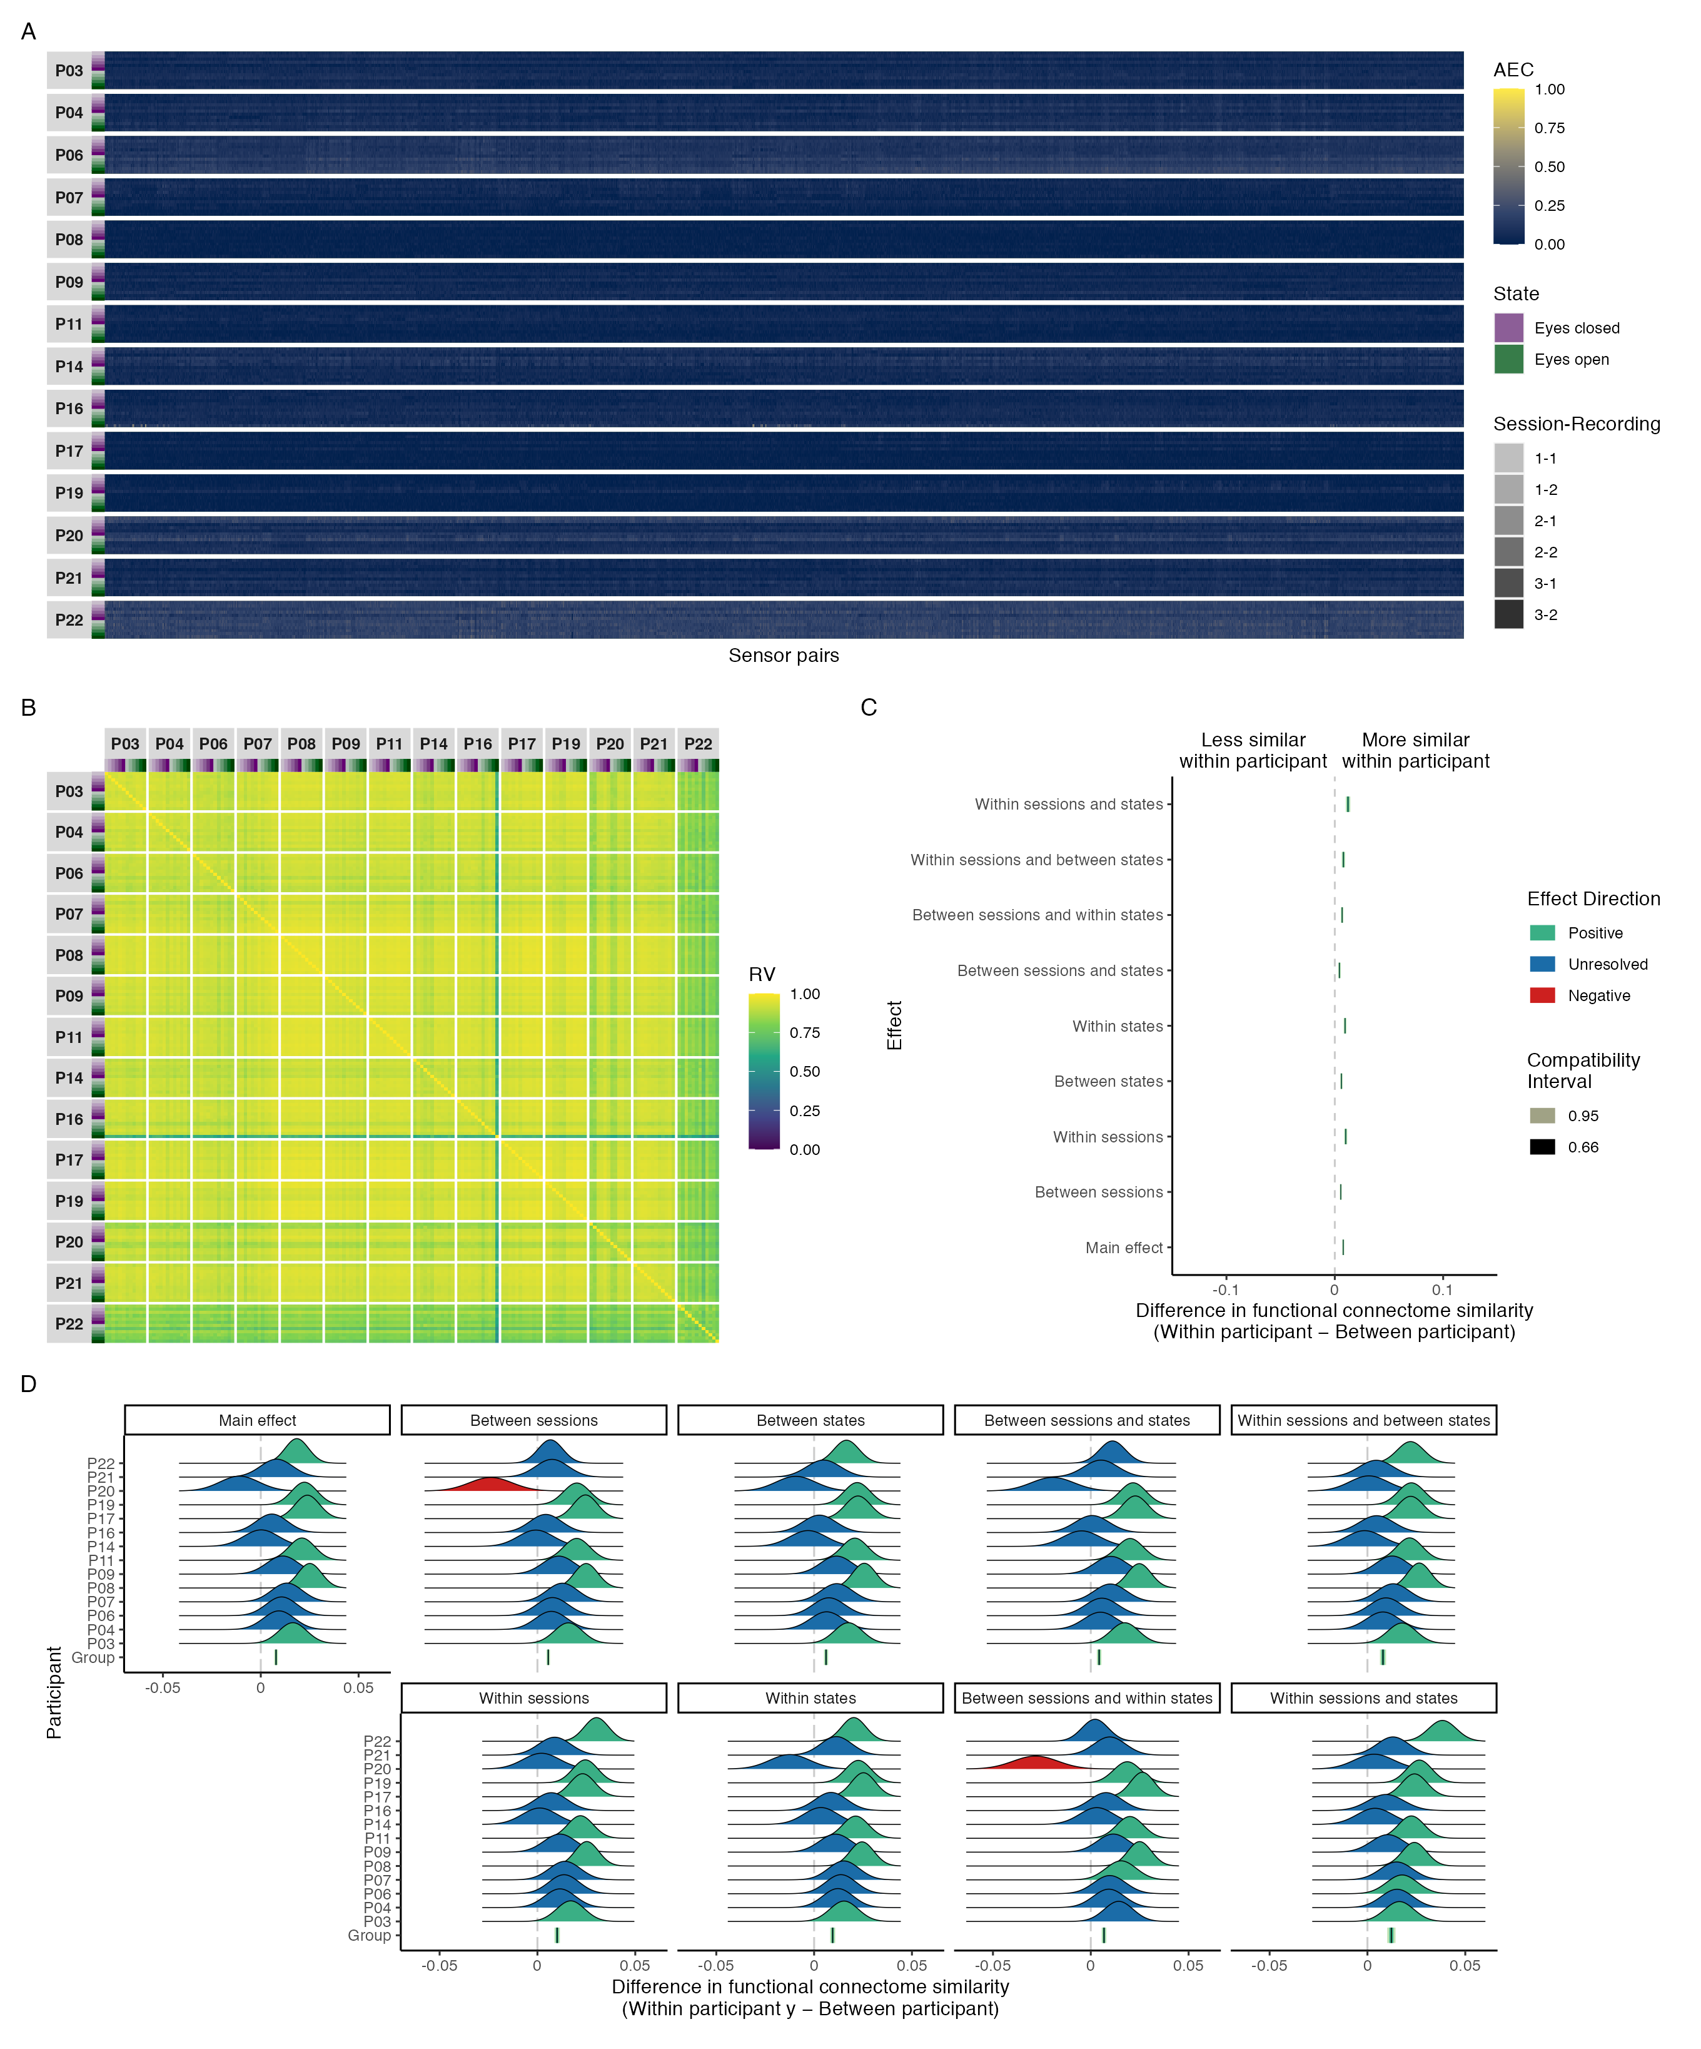

*Figure* *5.*  Connectivity profile matrix (A), similarity matrix (B), interval plot (C), and ridge plots (D) for amplitude coupling functional connectome similarities in the theta band.

## Alpha band

### Phase-coupling similarities.

Figure 6 shows the connectivity profile matrix, similarity matrix, interval, and ridge plots for phase coupling functional connectome similarities in the alpha band. Across all functional connectomes and sensor pairs, the phase lag index ranged from 0.04 to 0.88 (M = 0.24, SD = 0.13; Figure 6A). There were no visually obvious patterns of similarity consistent across participants, but there were some individual differences worth highlighting: Participant P03 showed high similarity across sessions and states, corresponding to an individual effect; Participants P14, P17, and P19 showed moderate to high similarity in the eyes open state across sessions, and moderate similarity between participants, corresponding to a partial state effect; and participants P07, P08, P11, and P20 showed moderate similarity across sessions and states with themselves and each other, corresponding to a partial group effect. The remaining participants showed no distinctive patterns. Additionally, unlike the delta and theta bands, the amount of similarity between participants was generally moderate and considerably more variable; not consistently high (Figure 6B). The group-level contrasts showed that functional connectomes were approximately two to four times more similar within participants than between participants at all levels of the session and state predictors, relative to the theta and delta bands, respectively. However, the effect sizes most compatible with our data, given the background model, were still at most small and not meaningful at all levels of the effect, with the exception of the within state and the within session and state effects, which showed effect sizes that were at most small but meaningful (Figure 6C). On average, differences in similarity were largest when contrasting functional connectomes from the same session and state ($Δ$ RV = 0.101, 95% CI = [0.088, 0.113]), and smallest when contrasting functional connectomes from different sessions and states ($Δ$ RV = 0.028, 95% CI = [0.021, 0.034]), with an overall difference of $Δ$ RV = 0.059, 95% CI = [0.054, 0.064]. The individual-level contrasts better highlight the inter-individual variability in functional connectome similarities at different levels of the effect, and again highlight that group-level contrasts should not be overinterpreted, given that the data did not resolve whether the most compatible effect sizes were positive or negative for roughly one-third of the participants at most levels of the session and state predictors. However, there was more individual-level consistency with the group-level contrasts for the within state and the within session and state effects, where nearly all participants had effect sizes that were consistently positive and reasonably compatible with values that were small and meaningful (6D).

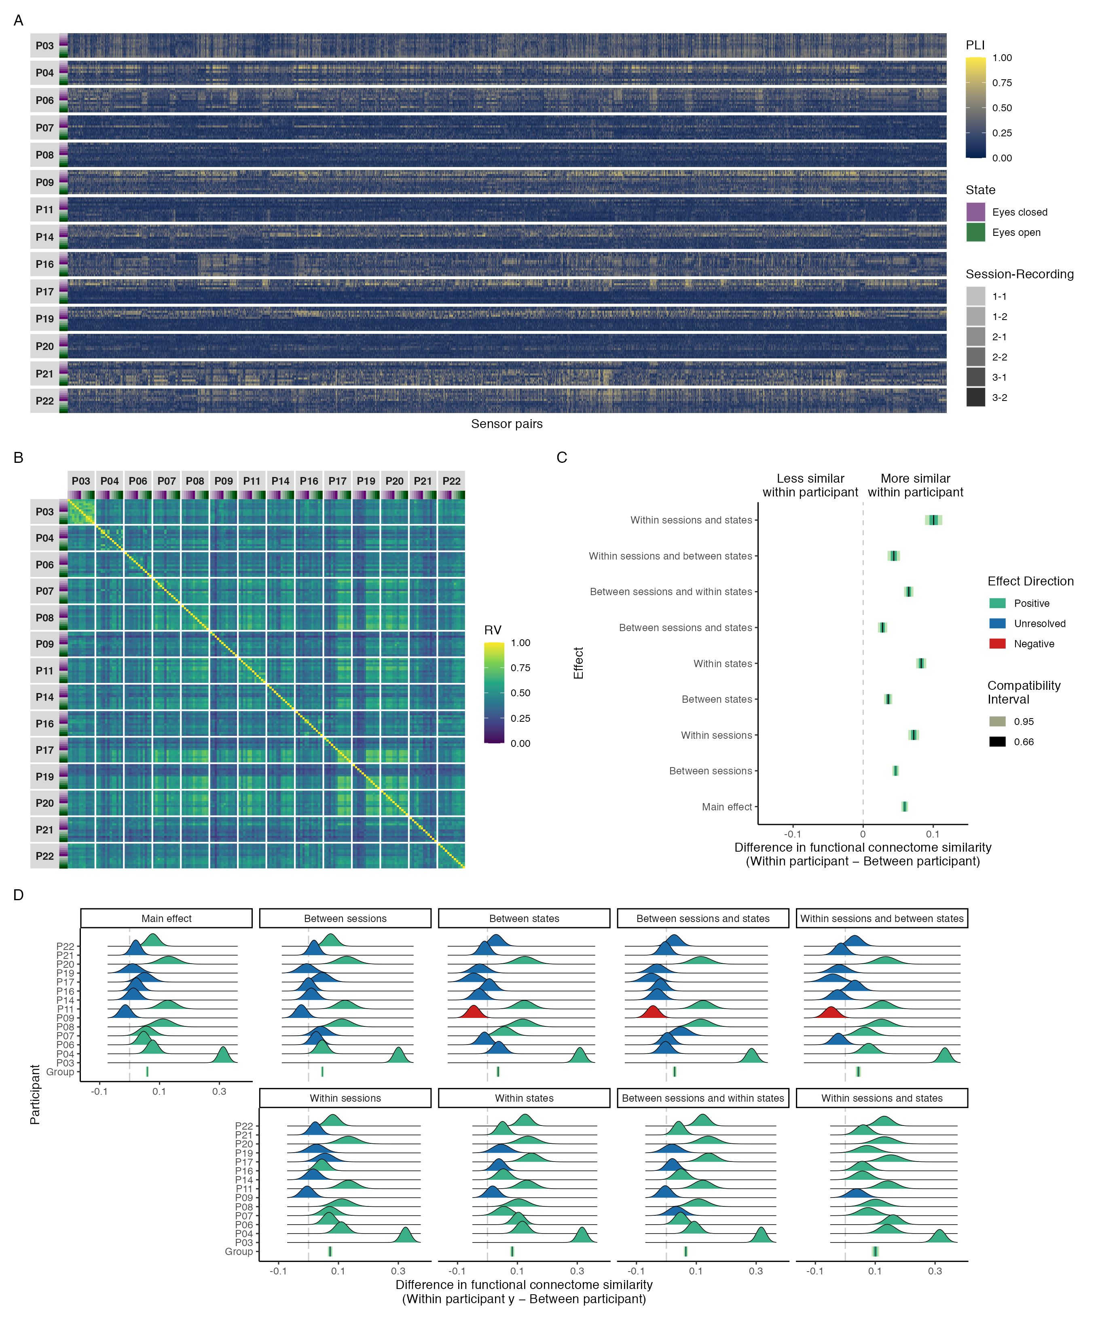

*Figure* *6.*  Connectivity profile matrix (A), similarity matrix (B), interval plot (C), and ridge plots (D) for phase coupling functional connectome similarities in the alpha band.

### Amplitude-coupling similarities.

Figure 7 shows the connectivity profile matrix, similarity matrix, interval, and ridge plots for amplitude coupling functional connectome similarities in the alpha band. Across all functional connectomes and sensor pairs, the orthogonalized amplitude envelope correlation ranged from 0.00 to 0.58 (M = 0.09, SD = 0.06; Figure 7A). Although there was high similarity between functional connectomes regardless of participant, session, or state—consistent with a group effect—there was noticeably more variability within and between participants than we found in the delta and theta bands, and nearly the same individual differences seen in Figure 6B with phase coupling functional connectome similarities were seen here (Figure 7B). This was reflected in the group-level contrasts, which showed that functional connectomes were more similar within participants than between participants at all levels of the session and state predictors, with effect sizes most compatible with our data, given the background model, that were at most small and not meaningful (Figure 7C). On average, differences in similarity were largest when contrasting functional connectomes from the same session and state ($Δ$ RV = 0.042, 95% CI = [0.036, 0.048]), and smallest when contrasting functional connectomes from different sessions and states ($Δ$ RV = 0.007, 95% CI = [0.004, 0.010]), with an overall difference of $Δ$ RV = 0.023, 95% CI = [0.020, 0.025]. The individual-level contrasts also showed similar individual differences as seen with phase coupling functional connectome similarities in Figure 6C, but with smaller magnitudes and variation (Figure 7D). However, the individual-level contrasts also made it clear that that the higher within participant similarity at the group-level should not be overinterpreted, given that the data did not resolve whether the most compatible effect sizes were positive or negative for roughly half the participants at most levels of the session and state predictors, and the roughly one-third of participants whose most compatible effect sizes were consistently positive were still at most small and not meaningful.

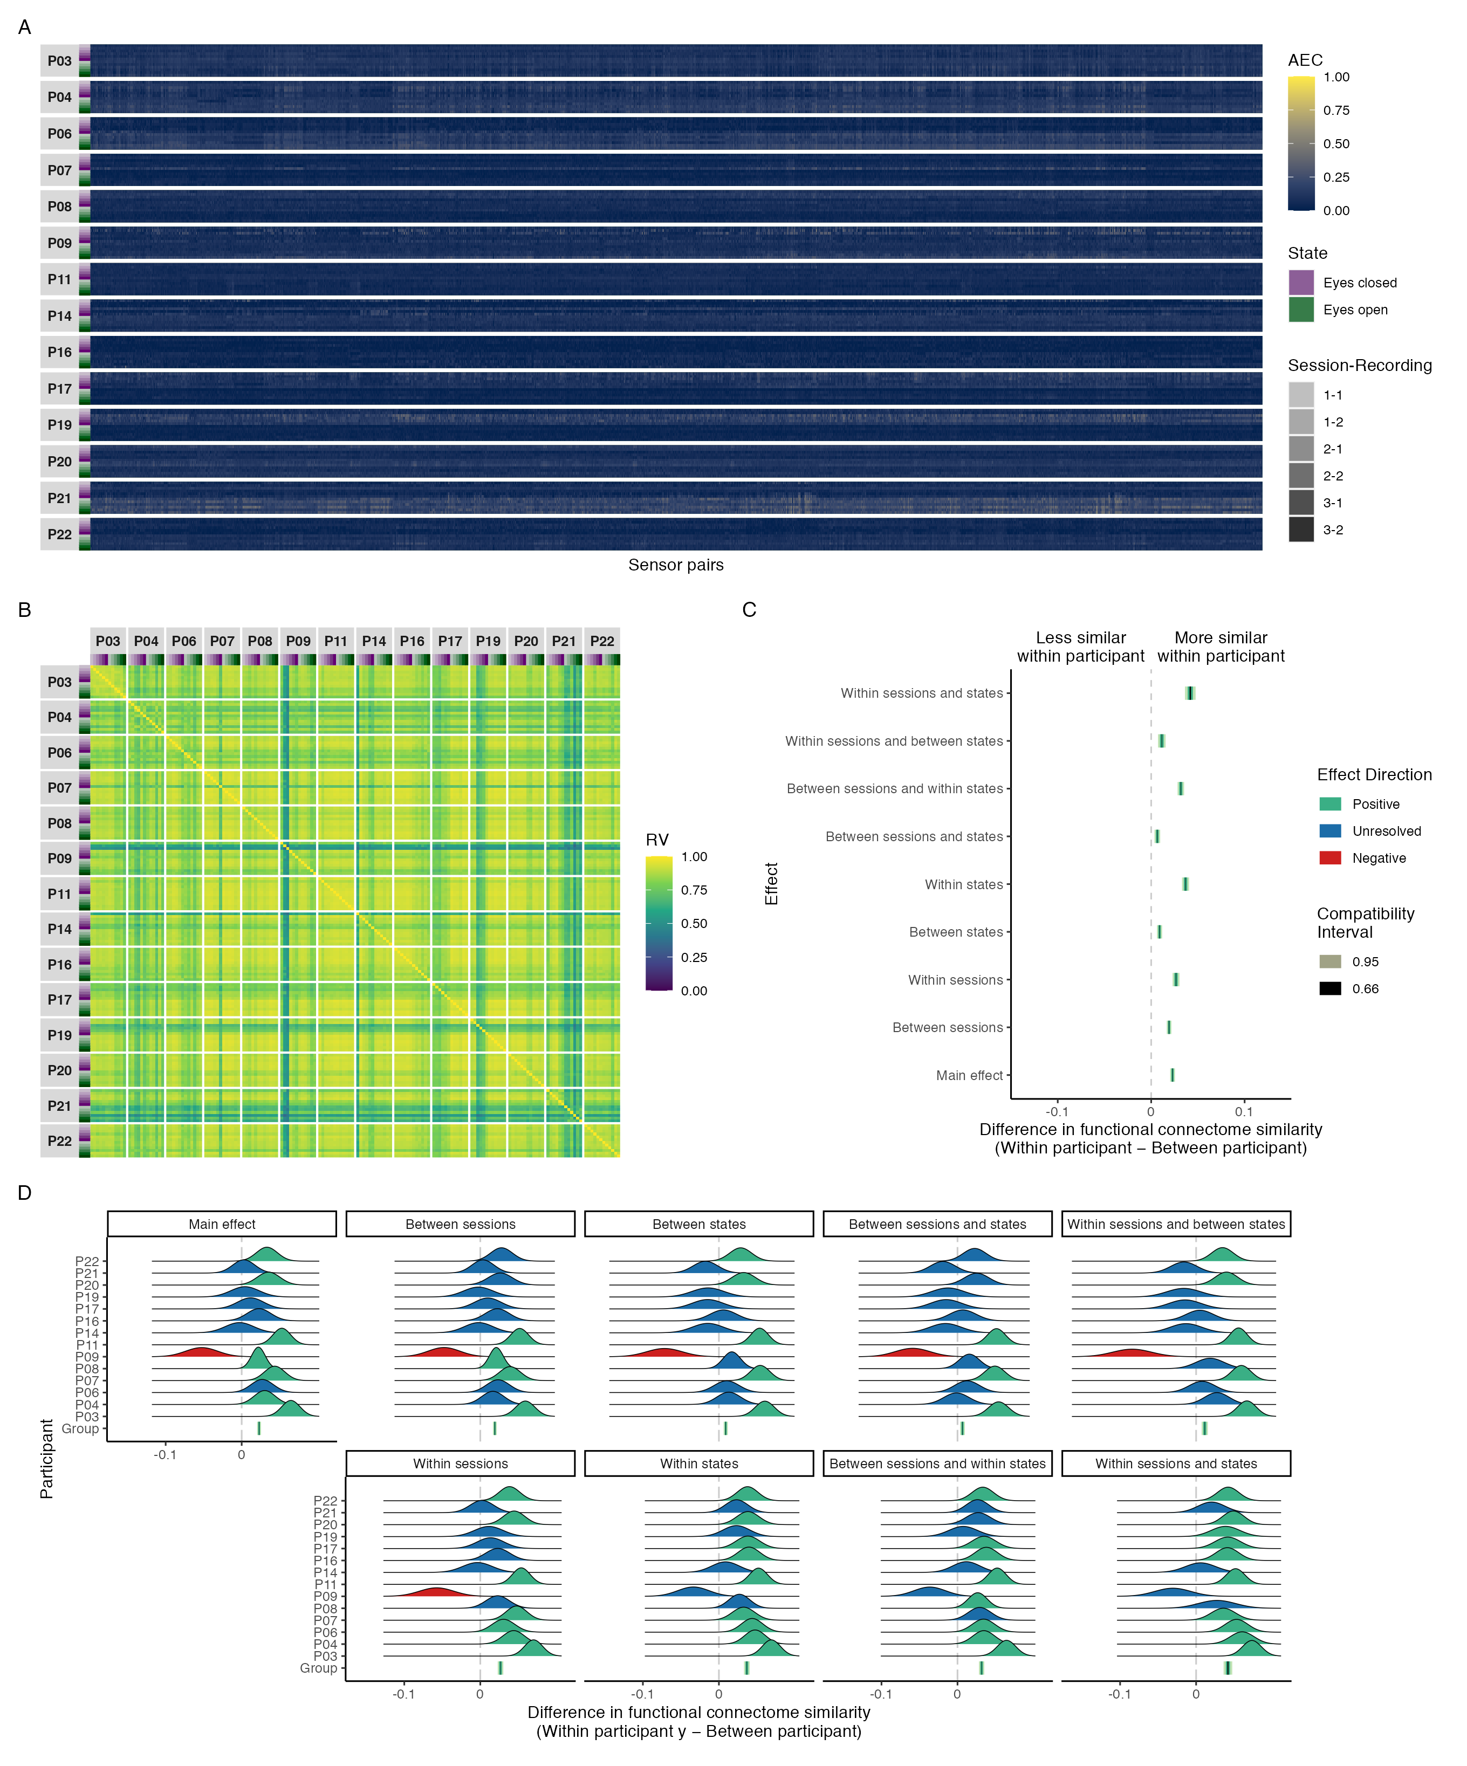

*Figure* *7.*  Connectivity profile matrix (A), similarity matrix (B), interval plot (C), and ridge plots (D) for amplitude coupling functional connectome similarities in the alpha band.

## Beta band

### Phase-coupling similarities.

Figure 8 shows the connectivity profile matrix, similarity matrix, interval, and ridge plots for phase coupling functional connectome similarities in the beta band. Across all functional connectomes and sensor pairs, the phase lag index ranged from 0.06 to 0.71 (M = 0.15, SD = 0.05; Figure 8A). There was a visually obvious group effect, with high similarity between functional connectomes regardless of participant, session, or state (Figure 8B)—but with slightly more variability within and between participants than we found with phase coupling functional connectomes in the delta and theta bands. This was reflected in the group-level contrasts, which showed that functional connectomes were somewhat more similar within participants than between participants at all levels of the session and state predictors, relative to the delta and theta bands; however, the effect sizes most compatible with our data, given the background model, were still at most small and not meaningful (Figure 8C). On average, differences in similarity were largest when contrasting functional connectomes from the same session and state ($Δ$ RV = 0.049, 95% CI = [0.043, 0.056]), and smallest when contrasting functional connectomes from different sessions and states ($Δ$ RV = 0.030, 95% CI = [0.026, 0.033]), with an overall difference of $Δ$ RV = 0.038, 95% CI = [0.035, 0.041]. Again the individual-level contrasts made it clear that the higher within participant similarity at the group-level should not be overinterpreted, given that the data did not resolve whether the most compatible effect sizes were positive or negative for roughly one-third of the participants at most levels of the session and state predictors; however, roughly two-thirds of the participants did have effect sizes that were consistently positive and reasonably compatible with values that were small and meaningful (8D).

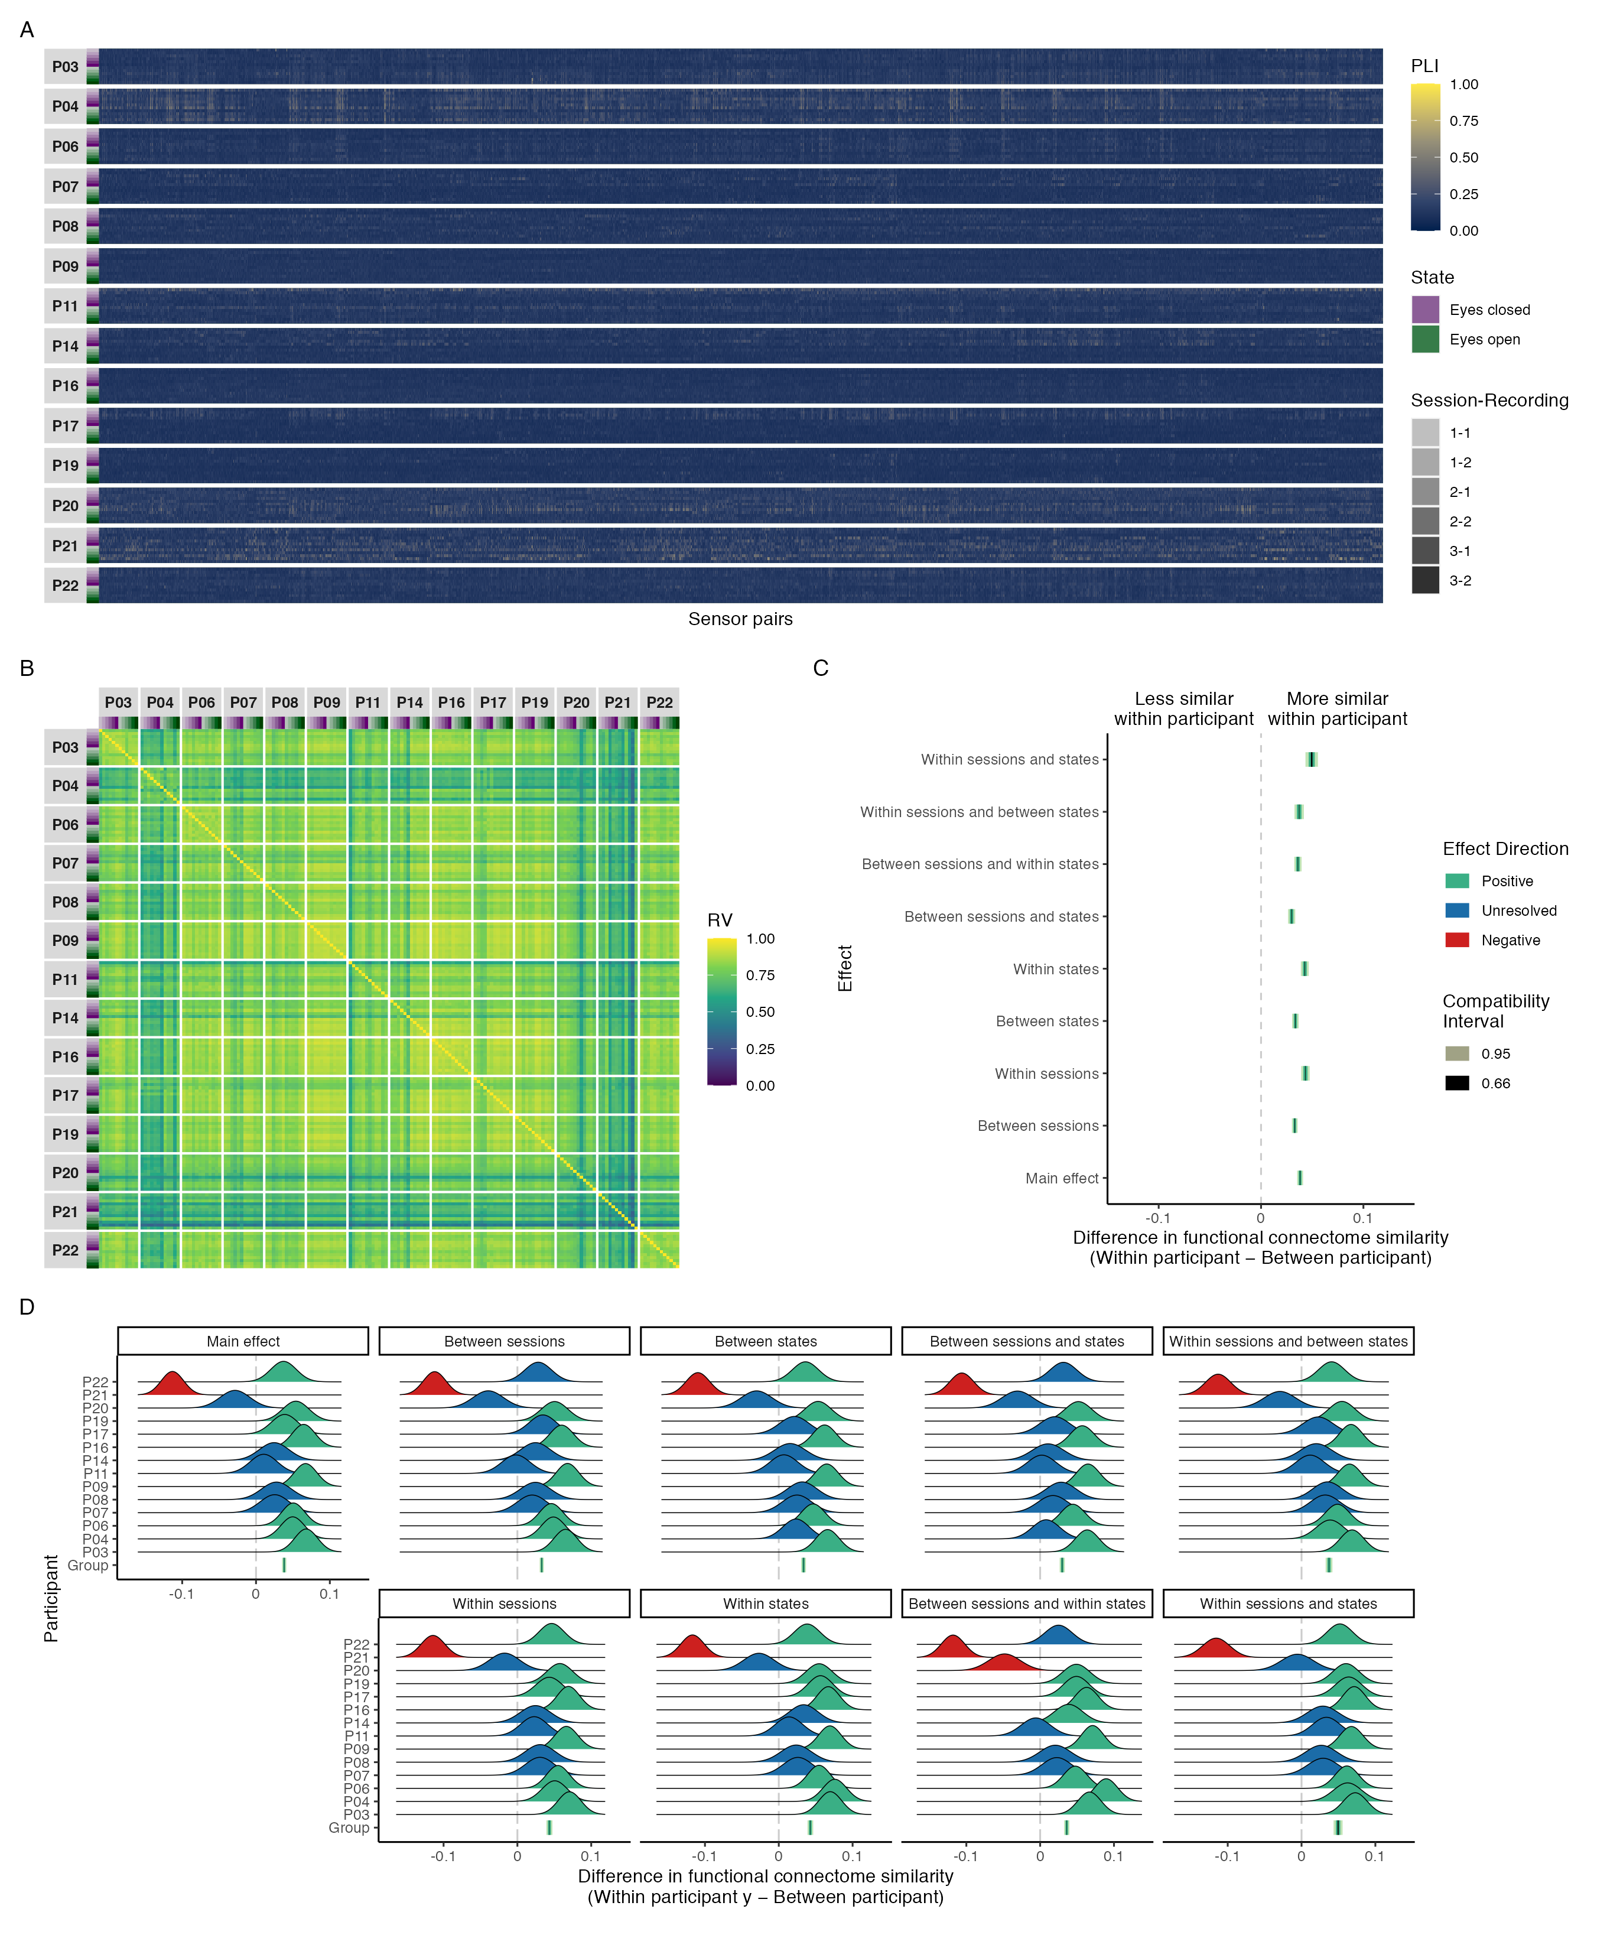

*Figure* *8.*  Connectivity profile matrix (A), similarity matrix (B), interval plot (C), and ridge plots (D) for phase coupling functional connectome similarities in the beta band.

### Amplitude-coupling similarities.

Figure 9 shows the connectivity profile matrix, similarity matrix, interval, and ridge plots for amplitude coupling functional connectome similarities in the beta band. Across all functional connectomes and sensor pairs, the orthogonalized amplitude envelope correlation ranged from 0.00 to 0.25 (M = 0.04, SD = 0.03; Figure 9A). There was a visually obvious group effect, with near-perfect similarity between functional connectomes regardless of participant, session, or state, like we saw in the delta and theta bands (Figure 9B). This was supported by the group-level contrasts, which showed that the differences in functional connectome similarity between and within individuals most compatible with our data, given the background model, were practically nil at all levels of the session and state predictors, with an overall difference of $Δ$ RV = 0.004, 95% CI = [0.003, 0.004] (Figure 9C).

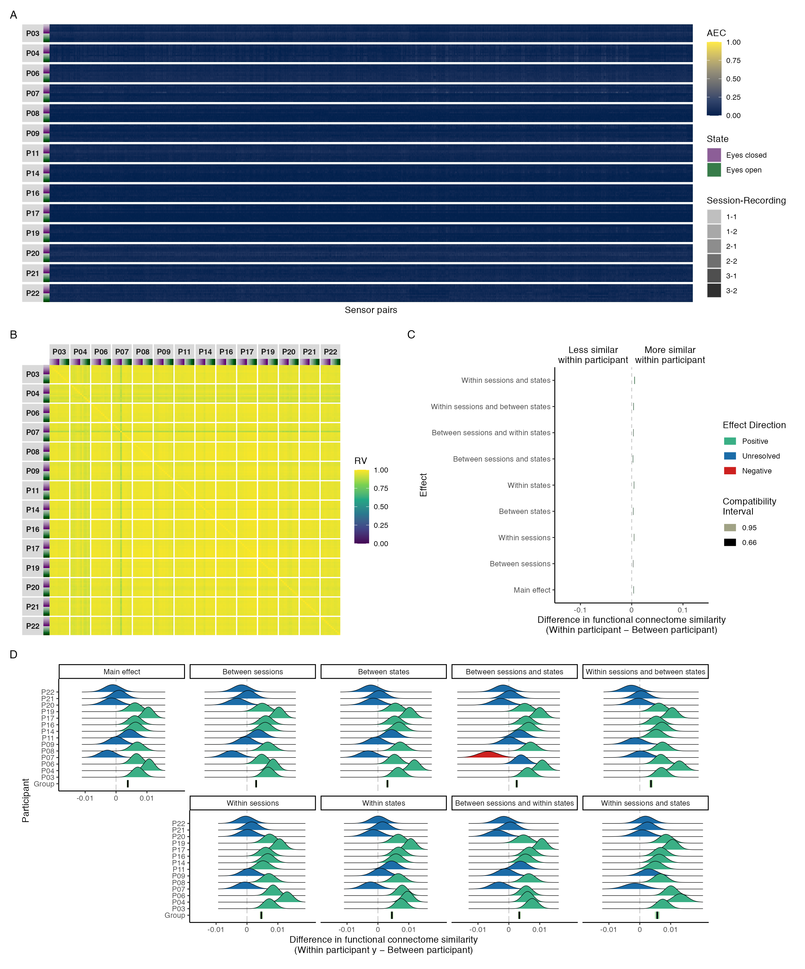

*Figure* *9.*  Connectivity profile matrix (A), similarity matrix (B), interval plot (C), and ridge plots (D) for amplitude coupling functional connectome similarities in the beta band.

## Gamma band

### Phase-coupling similarities.

Figure 10 shows the connectivity profile matrix, similarity matrix, interval, and ridge plots for phase coupling functional connectome similarities in the gamma band. Across all functional connectomes and sensor pairs, the phase lag index ranged from 0.06 to 0.99 (M = 0.14, SD = 0.06; Figure 10A). There was a visually obvious group effect, with high similarity between functional connectomes regardless of participant, session, or state for all participants but P21 (Figure 10B), with a similar degree of variability within and between participants as we found with phase coupling functional connectomes in the delta and theta band. This was supported by the group-level contrasts, which showed that although functional connectomes were more similar within participants than between participants at all levels of the session and state predictors, the effect sizes most compatible with our data, given the background model, were at most very small and not meaningful (Figure 10C). On average, differences in similarity were largest when contrasting functional connectomes from the same session and state ($Δ$ RV = 0.034, 95% CI = [0.026, 0.042]), and smallest when contrasting functional connectomes from different sessions and states ($Δ$ RV = 0.010, 95% CI = [0.006, 0.014]), with an overall difference of $Δ$ RV = 0.018, 95% CI = [0.015, 0.021]. Moreover, the individual-level contrasts also made it clear that the slightly higher within participant similarity at the group-level should not be overinterpreted, given that the data did not resolve whether the most compatible effect sizes were positive or negative for nearly all participants at most levels of the session and state predictors (Figure 10D).

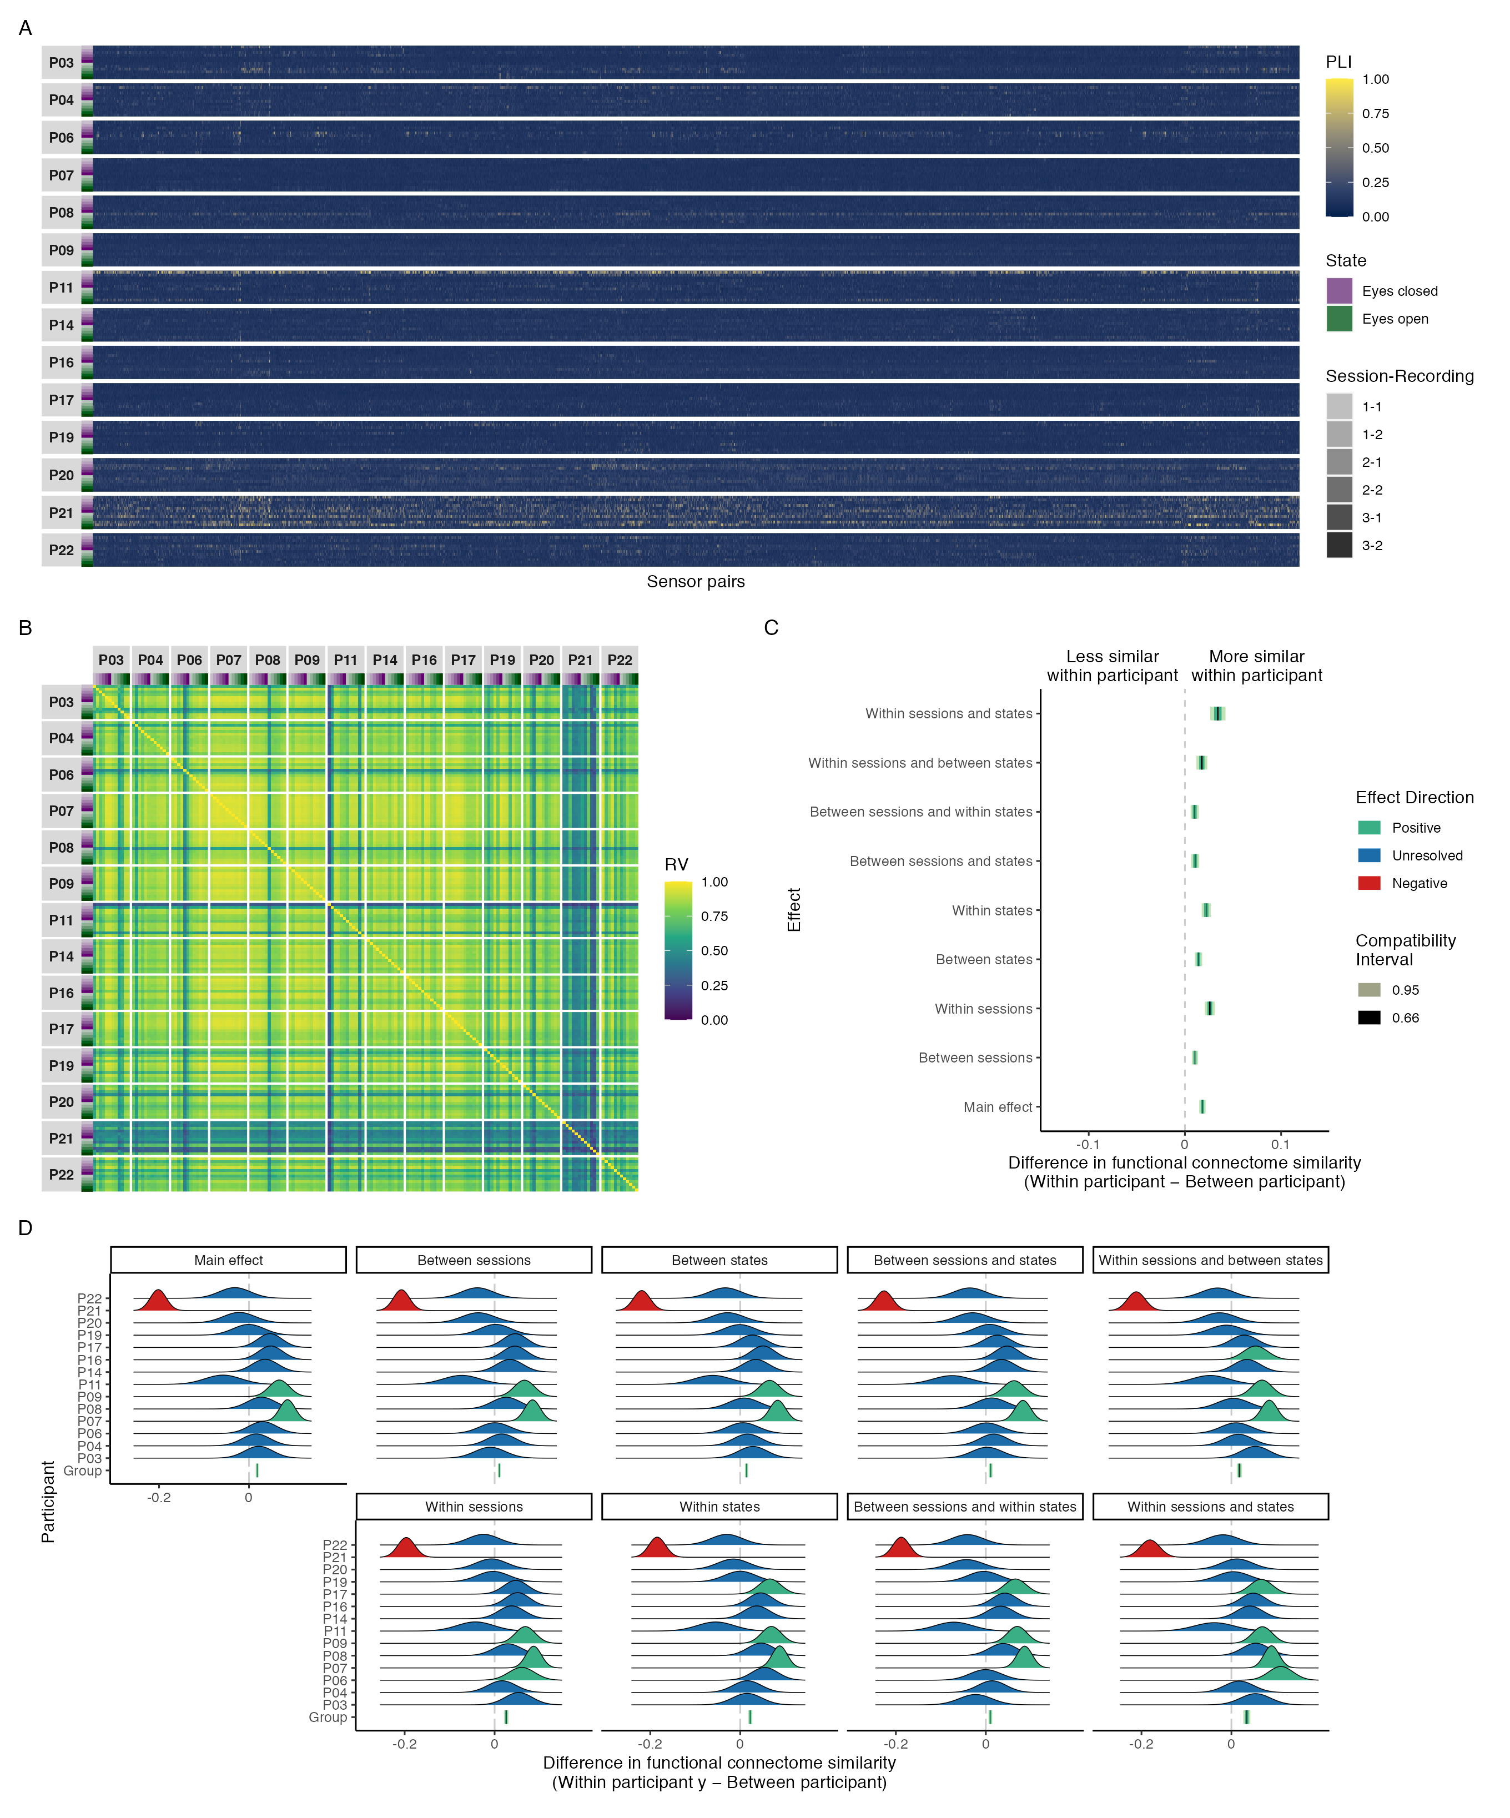

*Figure* *10.*  Connectivity profile matrix (A), similarity matrix (B), interval plot (C), and ridge plots (D) for phase coupling functional connectome similarities in the gamma band.

### Amplitude-coupling similarities.

Figure 11 shows the connectivity profile matrix, similarity matrix, interval, and ridge plots for amplitude coupling functional connectome similarities in the gamma band. Across all functional connectomes and sensor pairs, the orthogonalized amplitude envelope correlation ranged from 0.00 to 0.40 (M = 0.01, SD = 0.01; Figure 11A). There was a visually obvious group effect, with near-perfect similarity between functional connectomes regardless of participant, session, or state, like we saw in the delta, theta, and beta bands (Figure 9B). This was also apparent from the group- and individual-level contrasts, which showed that the differences in functional connectome similarity between and within individuals most compatible with our data, given the background model, were practically nil at all levels of the session and state predictors, with an overall difference of $Δ$ RV = 0.001, 95% CI = [0.001, 0.002] (Figure 11C).

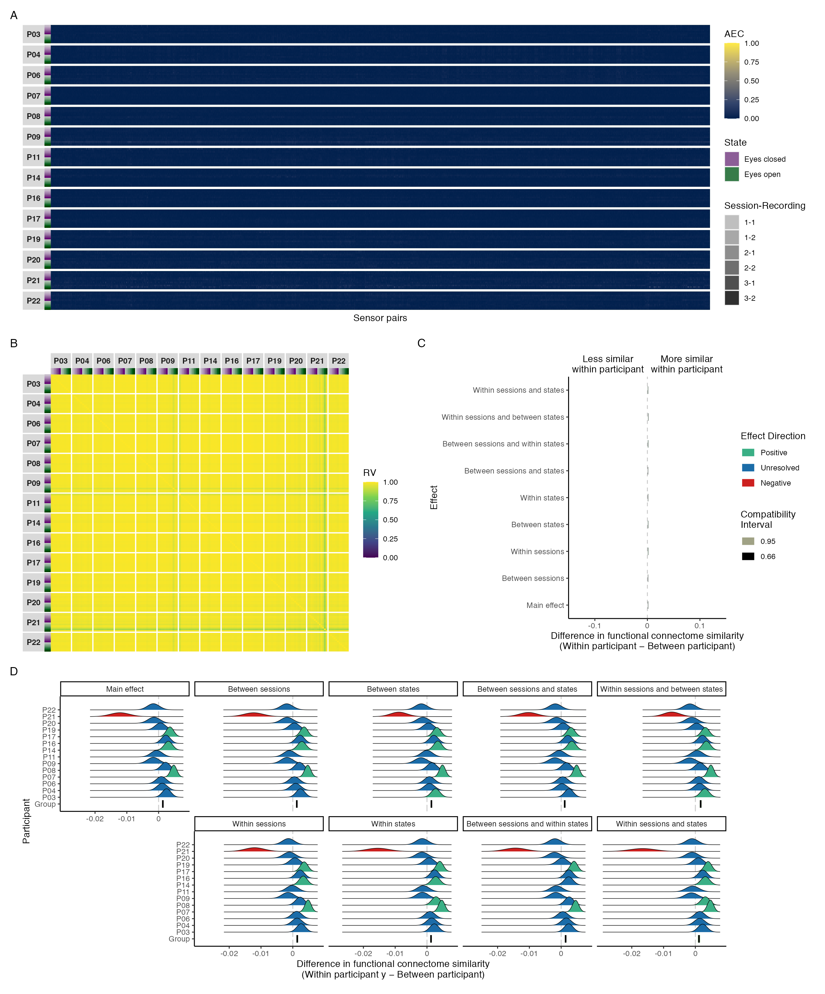

*Figure* *11.*  Connectivity profile matrix (A), similarity matrix (B), interval plot (C), and ridge plots (D) for amplitude coupling functional connectome similarities in the gamma band.

# Discussion

In this study, we explored the feasibility of using EEG to study network variants. We tested for the presence of network variants by estimating how phase and amplitude coupling functional connectomes differ between and within individuals across different timescales using measures of network similarity, contrasting the magnitude of each of these effects across sessions and states at the group-level, and examining their consistency at the individual-level. Based on the findings of previous fMRI network variant studies, we expected to find effects consistent with functional connectomes that were more similar within than between individuals, with smaller variations in similarity related to session or state—consistent with the idea that functional networks are stable and trait-like with equal amounts of common and unique variance between individuals (Gratton et al., 2018).

Overall, the group-level effect sizes most compatible with our data, given the background model, showed that both phase and amplitude coupling functional connectomes were more similar within than between individuals across timescales, with the strongest differences in similarity within and between individuals occurring for functional connectomes from the same session and state, and the weakest differences occurring for functional connectomes from the different sessions and states. However, in general, these effect sizes were at most small and not meaningful, or were practically nil in the case of delta, theta, beta, and gamma band amplitude coupling functional connectomes. In the few cases where effect sizes were considered meaningful, they were still at most small, and were not consistent with the larger differences reported in the fMRI literature (cf. Gratton et al., 2018). Moreover, these cases were often unrepresentative of the variability seen at the individual-level, where the data did not resolve whether the most compatible effect sizes were positive or negative for a considerable portion of participants at most levels of the session and state predictors across timescales. Although a number of participants did have consistently positive effect sizes that were small and meaningful—or comparable to fMRI effect sizes in a handful of cases—we would not consider these results to be consistent with the stable and trait-like characterization of functional networks reported in the fMRI literature (cf. Gratton et al., 2018), given that trait-like functional networks would theoretically create consistent differences for all participants. Considered together, at most our findings provided weak supportive evidence for the presence of network variants in a subset of our sample for phase coupling functional connectomes in the theta, alpha, beta, and gamma bands, but did not generally demonstrate the feasibility of using EEG to study network variants given the inconsistencies observed across participants.

## Differences between phase and amplitude coupling

Across all frequency bands, we found that functional connectivity estimated with the orthogonalized amplitude envelope correlation was generally weaker than with the phase lag index. This difference has also been previously found by Fraschini, Pani, Didaci, and Marcialis (2019), who tested the robustness of several functional connectivity metrics for biometric person identification (for a review of EEG biometrics, see H.-L. Chan et al., 2018). Given that the phase lag index and orthogonalized amplitude envelope correlation measure different aspects of functional connectivity, we expected them to differ (Engel et al., 2013). However, we also note that this difference is likely partially due to differences in the frequency specificity of the two methods, with the phase lag index having greater specificity than the orthogonalized amplitude envelope correlation. This difference in frequency specificity is attributable to the phase lag index being estimated and averaged over multiple frequency bins in each frequency band when using the multitaper method, versus the orthogonalized amplitude envelope correlation being estimated with a single analytic signal in each frequency band when using the Hilbert transform method. In Appendix Figures A1-A5 we show how the results change when the phase lag index is estimated using the Hilbert transform method. Across all five frequency bands we found that (1) functional connectivity was generally lower than we found with the multitaper method, but individual patterns of connectivity were similar or the same; and (2) functional connectome similarity was generally higher than we found with the multitaper method, but patterns of similarity and contrast effect sizes were similar or the same. Thus, although these changes were not great enough to change our conclusions, they did make the differences observed between the phase lag index and orthogonalized amplitude envelope correlation results less stark, and highlight how different spectral analysis methods can influence functional connectivity estimates if analysis parameters cannot be matched (cf. Bruns, 2004).

Another factor possibly contributing to the differences observed between the phase lag index and orthogonalized amplitude envelope correlation was the effect of epoch length on the two methods. Fraschini et al. (2016) compared the effect of non-overlapping epochs with variable length (1, 2, 4, 6, 8, 10, 12, 14 and 16 seconds) on broadband (1-20 Hz) functional connectivity estimates in a small sample of middle-aged adults during resting eyes-closed resting state. They found that group-level mean functional connectivity was higher for the phase lag index than the orthogonalized amplitude envelope correlation at 1-6 second long epochs, with more comparable estimates between the two methods with 8-16 second long epochs. They also found that group-level mean functional connectivity decreased as a function of epoch length, with the phase lag index and orthogonalized amplitude envelope correlation stabilizing at 12 and 6 second long epochs, respectively. Because Fraschini et al.’s (2016) results were based on broadband group-level mean functional connectivity, they are not directly comparable to our own findings; however, they do highlight how preprocessing decisions can (differentially) influence functional connectivity estimates. In the context of our study, we emphasize the need for future work to explore how preprocessing decisions can influence individual-level functional connectivity and network similarity estimates, with a focus on identifying approaches that can achieve both high within-individual and low between-individual functional connectome similarity.

## Consistency with related neurophysiological connectomics literature

Consistent with previous EEG research on resting state networks (Samogin et al., 2020), we found that functional connectivity was strongest in the alpha band, which is likely due to the fact that alpha band oscillations are dominant during resting state (Mantini, Perrucci, Gratta, Romani, & Corbetta, 2007; Marino, Arcara, Porcaro, & Mantini, 2019). Notably, the prominence of alpha band functional connectivity coincided with the strongest differences in functional connectome similarity within versus between individuals, which may indicate that EEG network variants are more sensitive to task state than fMRI network variants (cf. Gratton et al., 2018). In support of this point, although we found that the relative strength of both within and between individual similarities generally shifted in the same direction at different timescales, the variability of these shifts was greater between than within individuals, indicating that functional connectomes became more differentiated between individuals as a function timescale. The smaller changes we found within individuals were also consistent with previous EEG (Nentwich et al., 2020), electrocorticography (ECoG; Mostame & Sadaghiani, 2021), and magnetoencephalography (MEG; Colclough et al., 2016) research, which found that phase and amplitude coupling functional connectomes were generally stable within individuals, showing moderate to high similarity within and between sessions and states across timescales; with higher similarity for functional connectivity estimated with the orthogonalized amplitude envelope correlation than for the phase lag index as in Colclough et al. (2016).

Our results are also conceptually consistent with a recent study by Nentwich et al. (2020), who investigated the relationship between twelve phenotypic variables (age, sex, socioeconomic status, intelligence, and diagnostic assessments for sleep disturbance, behavioural and emotional problems, attention-deficit/hyperactivity disorder, anxiety, inattention, mood, internet addiction, distress tolerance) and phase coupling functional connectome similarities in a large sample of typically and atypically developing children and adolescents during resting in the delta, theta, alpha, and beta bands. They found that all twelve variables were unable to explain variation in functional connectome similarities between and among individuals in the delta, theta, alpha, and beta bands; with the exception of sex and age in the beta band. Although our study did not examine the relationship between any variables of interest and functional connectome similarity, the findings of Nentwich et al. (2020) indicate—similar to our findings—that (1) functional connectomes may become more differentiated between individuals as a function timescale, given they only found phenotype-connectome relationships in the beta band; and (2) network variants may be harder to detect with EEG. Regarding the latter point, Nentwich et al. (2020) also investigated the relationship between the aforementioned twelve variables and fMRI functional connectome similarities in the same sample. Here they found that four variables (age, sex, intelligence, and the assessment for behavioural and emotional problems) were able to explain variation in functional connectome similarities between and among individuals, suggesting that fMRI functional connectomes may better capture practically relevant information compared to EEG.

## Factors that may contribute to differences between EEG and fMRI

Factors that could explain the differences between our findings and what has been reported in the fMRI literature are the spatial and temporal resolutions of the two modalities, and the methods used to estimate functional connectivity.

Network variants are likely sensitive to the spatial resolution of the neuroimaging system used to study them, as this influences the precision with which individual differences in functional connectivity can be measured. For EEG, the number of electrodes and distance between them determines spatial resolution, with higher electrode density corresponding to higher spatial resolution (Ferree, Clay, & Tucker, 2001; Robinson et al., 2017; Ryynanen, Hyttinen, Laarne, & Malmivuo, 2004; Ryynanen, Hyttinen, & Malmivuo, 2006). With low electrode density, as in the 10-20 system, EEG typically has a spatial resolution of approximately 5 to 9 centimetres (Burle et al., 2015; Srinivasan, Tucker, & Murias, 1998). Higher density EEG systems can achieve a spatial resolution of up to 1 to 2 centimetres, but this still falls short of the spatial resolution of fMRI, which typically ranges from 500 microns to 4 millimetres (Glover, 2011). Because EEG functional connectomes are naturally spatially blurrier than fMRI functional connectomes, network variants may be harder to detect or less pronounced in EEG, leading to smaller, less consistent, differences in functional connectome similarity within versus between individuals.[2] Future work might address this possibility either by testing how individual differences in functional connectome similarity vary as a function of electrode density, or by using simultaneous EEG and fMRI (Mulert, 2013) to compare the strength and consistency of network variants between the two modalities in the same sample.

Network variants are also likely sensitive to the methods used to estimate functional connectivity. There are two assumptions related to this that are important to consider when evaluating our results, and which may be worth investigating in future research. First, we assumed that five minute recordings would be sufficient to get stable functional connectivity estimates with EEG given that (1) the longer scanning times needed to reliably detect network variants with fMRI is related to its low sampling rate (Seitzman et al., 2019), and not to the actual timeframe at which neural processes occur; and (2) EEG samples a substantially larger number of time points than fMRI in a much shorter timeframe. Because we found that functional connectomes were generally stable within individuals, showing moderate to high similarity within and between sessions and states across timescales, we believe this assumption was justified. However, we do note that longer recordings have been found to improve the stability of fMRI functional connectivity estimates in a qualitatively distinct way from higher sampling rates (Birn et al., 2013), likely due to slow network changes being more fully captured by longer recordings. Future work may benefit from testing if the stability of EEG functional connectivity estimates gain a similar improvement from longer recordings, particularly at slower timescales such as the delta band.

Second, we assumed that network variants could be observed when considering only phase and amplitude coupling with non-zero lag, discounting the true zero-lag coupling that occurs in functional networks. However, this discounting leads to an underestimation of true connectivity for both the phase lag index and amplitude envelope correlation by a non-trivial amount (Fraschini et al., 2019; Hipp et al., 2012; Stam et al., 2007). Given that we generally found the strongest similarities between functional connectomes with homogeneously low patterns of coupling, non-zero lag phase and amplitude coupling methods may not be feasible for studying network variants at timescales where coupling is expected to be generally lower for a given state or task. The most extreme examples of this in our study were with amplitude coupling functional connectomes in the delta, theta, beta, and gamma bands, where we found that surprisingly high similarity within and between individuals was associated with functional connectomes with surprisingly low coupling across sensors for all connectomes. Because of the homogeneously low patterns of coupling, we would argue that these cases of high similarity are not particularly interesting, and should likely be treated as a methodological artifact.

One potential solution to avoid homogeneously low patterns of coupling would be to use phase and amplitude coupling methods that include zero-lag coupling—supplemented with tests against volume conduction (Cohen, 2014). However, this approach is impractical for EEG connectomics research since it requires inspecting hundreds of thousands of individual connections to rule out possible contamination by volume conduction. Another potential solution would be to use non-zero lag coupling methods that might underestimate true connectivity by a lesser amount, such as the weighted phase lag index (Vinck et al., 2011) for phase coupling. We are not aware of an equivalent weighted non-zero lag method for amplitude coupling. For future work, this may mean that in cases where it is impractical to estimate zero-lag amplitude coupling with tests against volume conduction, it may be better not to use amplitude coupling methods at all. Regardless, the spatial mixing caused by volume conduction poses a difficult problem, and future work may benefit from testing the robustness of different functional connectivity methods for studying network variants with EEG (for a related example using magnetoencephalography, see Colclough et al., 2016).

## Limitations

In addition to the discussion above, the following methodological and statistical assumptions are important to consider when evaluating our results.

First, it is unclear how our results might generalize to more diverse samples. In particular, our participants were healthy young adults in their twenties sampled from a western, educated, industrialized, rich, and democratic population, who have been shown to be outliers on a number of behavioural and cognitive measures in comparison with the rest of the human population (Henrich, Heine, & Norenzayan, 2010). Differences in in functional connectivity have been found with ageing (e.g., Samogin, Rueda Delgado, Taberna, Swinnen, & Mantini, 2022), neurological disease or disorder (e.g., Engels et al., 2015), mental illnesses such as depression (e.g., Shim, Im, Kim, & Lee, 2018), head trauma (e.g., C. Cao & Slobounov, 2010), and alcoholism (e.g., R. Cao, Wu, Li, Xiang, & Chen, 2014); thus, it might be reasonable to expect that our exclusion criteria removed meaningful variation from our sample. Additionally, given the size of our sample, and the inconsistencies we observed across participants, we would also caution against generalizing our results to samples with similar characteristics. At most we might conclude that—if network variants can be reliably detected with EEG—there is no guarantee that their presence can be detected in a given individual or data set, given the background models used to estimate functional connectivity and test for their presence.

Second, we assumed that the connectivity structure in each frequency band was stationary over the length of the recording for both phase and amplitude coupling functional connectomes. Although neural oscillations are naturally non-stationary, varying from moment to moment (Faisal, Selen, & Wolpert, 2008), stationary patterns of functional connectivity during resting state have been identified in EEG (e.g., Olguín-Rodríguez et al., 2018), fMRI (e.g., Laumann et al., 2017), and simultaneous EEG-fMRI studies (e.g., Daniel Arzate-Mena et al., 2022), with consistent positive or negative coupling occurring between sites or electrodes, even when averaging over multiple epochs. These stationary patterns are thought to be the substrate for effective brain function, permitting the adaptability and efficiency needed to optimize responses to our often unpredictable environment (Garrett et al., 2013), and thus reflect neuropsychologically relevant signals of interest. However, we do note that approaches accounting for nonlinear dynamics may provide complimentary insights to those that focus on the stable aspects of network variants. For example, Van De Ville, Farouj, Preti, Liégeois, and Amico (2021) found that fMRI functional connectomes exhibit short transient bursts of uniqueness even at short time windows, with different resting state networks becoming more or less unique between individuals as a function of time window length, suggesting that the dynamic aspects of network variants are worth exploring.

Finally, we limited our investigation to within-frequency analyses of functional connectivity and network similarity. Although cross-frequency coupling is also considered to be a key mechanism by which the brain transmits and processes information, integrating functional systems across multiple spatiotemporal scales (Canolty & Knight, 2010), we did not explore for the presence of network variants in cross-frequency coupling functional connectomes given that most research on cross-frequency coupling focuses on coupling within brain regions or between a small number of regions of interest, rather than the entire connectome. Only a handful of studies have demonstrated that cross-frequency coupling also occurs in whole brain functional networks (Keitel, Thut, & Gross, 2017; Palva, 2005; Siebenhühner, Wang, Palva, & Palva, 2016; van der Meij, Kahana, & Maris, 2012), and the validity of these findings has recently come into question due to standard cross-frequency coupling analyses showing significant cross-frequency coupling in the absence of any underlying physiological coupling (Aru et al., 2015). Recently, however, Siebenhühner et al. (2020) were able to demonstrate the presence of true cross-frequency coupling in whole brain functional networks—ruling out the influence of spurious coupling—in both a small sample of presurgical epilepsy patients during eyes-closed resting state using stereo-EEG, and a small sample of healthy controls during eyes-open resting state using magnetoencephalography. Moreover, they found that network strength was predictive of individual differences on several cognitive tasks in the healthy control sample (the other sample did not complete these tasks); thus, cross-frequency coupling may be a worthwhile avenue for future EEG network variant research if methods for estimating true cross-frequency coupling are validated, improved, and made more accessible (e.g., Idaji et al., 2022).

## Conclusion

In this study, we explored the feasibility of using EEG to study network variants. We found at most weak supportive evidence for the presence of network variants in a subset of our sample for phase coupling functional connectomes in the theta, alpha, beta, and gamma bands, but did not generally demonstrate the feasibility of using EEG to study network variants given the inconsistencies observed across participants. In future studies, it would be interesting to see whether network variants in EEG functional connectomes can be made more consistent through state or task manipulations that are known to bring out meaningful differences between participants (Finn, 2021; Finn & Bandettini, 2020; Finn et al., 2020; Finn et al., 2017); or to systematically investigate how decisions related to preprocessing or functional connectivity estimation influence the structure of EEG functional connectomes and their similarity within and between individuals, across tasks, states, and over time (Colclough et al., 2016; Fraschini et al., 2019).

# References

Abdi, Hervé. (2007). *RV Coefficient and Congruence Coefficient*.

Ablin, P., Cardoso, J.-F., & Gramfort, A. (2017). Faster ICA under orthogonal constraint. *arXiv:1711.10873 [Stat]*. Retrieved from <http://arxiv.org/abs/1711.10873>

Ablin, P., Cardoso, J.-F., & Gramfort, A. (2018). Faster independent component analysis by preconditioning with Hessian approximations. *IEEE Transactions on Signal Processing*, *66*(15), 4040–4049. <https://doi.org/10.1109/TSP.2018.2844203>

Alexander, L. M., Escalera, J., Ai, L., Andreotti, C., Febre, K., Mangone, A., … Milham, M. P. (2017). An open resource for transdiagnostic research in pediatric mental health and learning disorders. *Scientific Data*, *4*(1), 1–26. <https://doi.org/10.1038/sdata.2017.181>

Allaire, J., Xie, Y., McPherson, J., Luraschi, J., Ushey, K., Atkins, A., … Iannone, R. (2022). *Rmarkdown: Dynamic documents for r*. Retrieved from <https://CRAN.R-project.org/package=rmarkdown>

Amrhein, V., & Greenland, S. (2022). Discuss practical importance of results based on interval estimates and p-value functions, not only on point estimates and null p-values. *Journal of Information Technology*, 02683962221105904. <https://doi.org/10.1177/02683962221105904>

Amrhein, V., Greenland, S., & McShane, B. (2019). Scientists rise up against statistical significance. *Nature*, *567*(7748), 305–307. <https://doi.org/10.1038/d41586-019-00857-9>

Anderson, J. S., Ferguson, M. A., Lopez-Larson, M., & Yurgelun-Todd, D. (2011). Reproducibility of Single-Subject Functional Connectivity Measurements. *American Journal of Neuroradiology*, *32*(3), 548–555. <https://doi.org/10.3174/ajnr.A2330>

Aru, J., Aru, J., Priesemann, V., Wibral, M., Lana, L., Pipa, G., … Vicente, R. (2015). Untangling cross-frequency coupling in neuroscience. *Current Opinion in Neurobiology*, *31*, 51–61. <https://doi.org/10.1016/j.conb.2014.08.002>

Aust, F., & Barth, M. (2022). *Papaja: Prepare american psychological association journal articles with r markdown*. Retrieved from <https://github.com/crsh/papaja>

Babadi, B., & Brown, E. N. (2014). A review of multitaper spectral analysis. *IEEE transactions on bio-medical engineering*, *61*(5), 1555–1564. <https://doi.org/10.1109/TBME.2014.2311996>

Bastos, A. M., & Schoffelen, J.-M. (2016). A Tutorial Review of Functional Connectivity Analysis Methods and Their Interpretational Pitfalls. *Frontiers in Systems Neuroscience*, *9*. <https://doi.org/10.3389/fnsys.2015.00175>

Birn, R. M., Molloy, E. K., Patriat, R., Parker, T., Meier, T. B., Kirk, G. R., … Prabhakaran, V. (2013). The effect of scan length on the reliability of resting-state fMRI connectivity estimates. *NeuroImage*, *83*, 550–558. <https://doi.org/10.1016/j.neuroimage.2013.05.099>

Brooks, M., E., Kristensen, K., Benthem, K., J.,van, Magnusson, A., Berg, C., W., Nielsen, A., … Bolker, B., M. (2017). glmmTMB Balances Speed and Flexibility Among Packages for Zero-inflated Generalized Linear Mixed Modeling. *The R Journal*, *9*(2), 378. <https://doi.org/10.32614/RJ-2017-066>

Bruns, A. (2004). Fourier-, Hilbert- and wavelet-based signal analysis: are they really different approaches? *Journal of Neuroscience Methods*, *137*(2), 321–332. <https://doi.org/10.1016/j.jneumeth.2004.03.002>

Burle, B., Spieser, L., Roger, C., Casini, L., Hasbroucq, T., & Vidal, F. (2015). Spatial and temporal resolutions of EEG: Is it really black and white? A scalp current density view. *International Journal of Psychophysiology*, *97*(3), 210–220. <https://doi.org/10.1016/j.ijpsycho.2015.05.004>

Buzsáki, G. (2011). *Rhythms of the Brain* (Illustrated edition). Oxford ; New York: Oxford University Press.

Buzsáki, G., & Draguhn, A. (2004). Neuronal Oscillations in Cortical Networks. *Science*, *304*(5679), 1926–1929. <https://doi.org/10.1126/science.1099745>

Campitelli, E. (2022). *Ggnewscale: Multiple fill and colour scales in ggplot2*. Retrieved from <https://CRAN.R-project.org/package=ggnewscale>

Canolty, R. T., & Knight, R. T. (2010). The functional role of cross-frequency coupling. *Trends in Cognitive Sciences*, *14*(11), 506–515. <https://doi.org/10.1016/j.tics.2010.09.001>

Cao, C., & Slobounov, S. (2010). Alteration of Cortical Functional Connectivity as a Result of Traumatic Brain Injury Revealed by Graph Theory, ICA, and sLORETA Analyses of EEG Signals. *IEEE Transactions on Neural Systems and Rehabilitation Engineering*, *18*(1), 11–19. <https://doi.org/10.1109/TNSRE.2009.2027704>

Cao, R., Wu, Z., Li, H., Xiang, J., & Chen, J. (2014). Disturbed Connectivity of EEG Functional Networks in Alcoholism: A Graph-Theoretic Analysis. *Bio-Medical Materials and Engineering*, *24*(6), 2927–2936. <https://doi.org/10.3233/BME-141112>

Capilla, A., Arana, L., García-Huéscar, M., Melcón, M., Gross, J., & Campo, P. (2022). The natural frequencies of the resting human brain: an MEG-based atlas. *NeuroImage*, 119373. <https://doi.org/10.1016/j.neuroimage.2022.119373>

Chan, H.-L., Kuo, P.-C., Cheng, C.-Y., & Chen, Y.-S. (2018). Challenges and Future Perspectives on Electroencephalogram-Based Biometrics in Person Recognition. *Frontiers in Neuroinformatics*, *12*. <https://doi.org/10.3389/fninf.2018.00066>

Chan, M. Y., Han, L., Carreno, C. A., Zhang, Z., Rodriguez, R. M., LaRose, M., … Wig, G. S. (2021). Long-term prognosis and educational determinants of brain network decline in older adult individuals. *Nature Aging*, *1*(11), 1053–1067. <https://doi.org/10.1038/s43587-021-00125-4>

Chatrian, G. E., Lettich, E., & Nelson, P. L. (1985). Ten Percent Electrode System for Topographic Studies of Spontaneous and Evoked EEG Activities. *American Journal of EEG Technology*, *25*(2), 83–92. <https://doi.org/10.1080/00029238.1985.11080163>

Chatrian, G. E., Lettich, E., & Nelson, P. L. (1988). Modified nomenclature for the “10%” electrode system. *Journal of Clinical Neurophysiology: Official Publication of the American Electroencephalographic Society*, *5*(2), 183–186.

Cnudde, K., van Hees, S., Brown, S., van der Wijk, G., Pexman, P. M., & Protzner, A. B. (2021). Increased Neural Efficiency in Visual Word Recognition: Evidence from Alterations in Event-Related Potentials and Multiscale Entropy. *Entropy*, *23*(3), 304. <https://doi.org/10.3390/e23030304>

Cohen, M. X. (2014). *Analyzing neural time series data: theory and practice*. Cambridge, Massachusetts: The MIT Press.

Cohen, M. X. (2017). Where Does EEG Come From and What Does It Mean? *Trends in Neurosciences*, *40*(4), 208–218. <https://doi.org/10.1016/j.tins.2017.02.004>

Colclough, G. L., Woolrich, M. W., Tewarie, P. K., Brookes, M. J., Quinn, A. J., & Smith, S. M. (2016). How reliable are MEG resting-state connectivity metrics? *NeuroImage*, *138*, 284–293. <https://doi.org/10.1016/j.neuroimage.2016.05.070>

Cribari-Neto, F., & Zeileis, A. (2010). Beta Regression in R. *Journal of Statistical Software*, *34*(2). <https://doi.org/10.18637/jss.v034.i02>

Daniel Arzate-Mena, J., Abela, E., Olguín-Rodríguez, P. V., Ríos-Herrera, W., Alcauter, S., Schindler, K., … Rummel, C. (2022). Stationary EEG pattern relates to large-scale resting state networks – An EEG-fMRI study connecting brain networks across time-scales. *NeuroImage*, *246*, 118763. <https://doi.org/10.1016/j.neuroimage.2021.118763>

de Cheveigné, A., & Nelken, I. (2019). Filters: When, Why, and How (Not) to Use Them. *Neuron*, *102*(2), 280–293. <https://doi.org/10.1016/j.neuron.2019.02.039>

Demuru, M., Gouw, A. A., Hillebrand, A., Stam, C. J., van Dijk, B. W., Scheltens, P., … Visser, P. J. (2017). Functional and effective whole brain connectivity using magnetoencephalography to identify monozygotic twin pairs. *Scientific Reports*, *7*(1), 9685. <https://doi.org/10.1038/s41598-017-10235-y>

Douma, J. C., & Weedon, J. T. (2019). Analysing continuous proportions in ecology and evolution: A practical introduction to beta and Dirichlet regression. *Methods in Ecology and Evolution*, *10*(9), 1412–1430. <https://doi.org/10.1111/2041-210X.13234>

Dubois, J., & Adolphs, R. (2016). Building a science of individual differences from fMRI. *Trends in Cognitive Sciences*, *20*(6), 425–443. <https://doi.org/10.1016/j.tics.2016.03.014>

Dunn, P. K., & Smyth, G. K. (1996). Randomized Quantile Residuals. *Journal of Computational and Graphical Statistics*, *5*(3), 236. <https://doi.org/10.2307/1390802>

Elliott, M. L., Knodt, A. R., Cooke, M., Kim, M. J., Melzer, T. R., Keenan, R., … Hariri, A. R. (2019). General functional connectivity: Shared features of resting-state and task fMRI drive reliable and heritable individual differences in functional brain networks. *NeuroImage*, *189*, 516–532. <https://doi.org/10.1016/j.neuroimage.2019.01.068>

Elliott, M. L., Knodt, A. R., Ireland, D., Morris, M. L., Poulton, R., Ramrakha, S., … Hariri, A. R. (2020). What Is the Test-Retest Reliability of Common Task-Functional MRI Measures? New Empirical Evidence and a Meta-Analysis. *Psychological Science*, 1–15. <https://doi.org/10.1177/0956797620916786>

Engel, A. K., Gerloff, C., Hilgetag, C. C., & Nolte, G. (2013). Intrinsic Coupling Modes: Multiscale Interactions in Ongoing Brain Activity. *Neuron*, *80*(4), 867–886. <https://doi.org/10.1016/j.neuron.2013.09.038>

Engels, M. M., Stam, C. J., van der Flier, W. M., Scheltens, P., de Waal, H., & van Straaten, E. C. (2015). Declining functional connectivity and changing hub locations in Alzheimer’s disease: an EEG study. *BMC Neurology*, *15*(1), 145. <https://doi.org/10.1186/s12883-015-0400-7>

Escoufier, Y. (1973). Le Traitement des Variables Vectorielles. *Biometrics*, *29*(4), 751. <https://doi.org/10.2307/2529140>

Faisal, A. A., Selen, L. P. J., & Wolpert, D. M. (2008). Noise in the nervous system. *Nature Reviews. Neuroscience*, *9*(4), 292–303. <https://doi.org/10.1038/nrn2258>

Fedorenko, E. (2021). The early origins and the growing popularity of the individual-subject analytic approach in human neuroscience. *Current Opinion in Behavioral Sciences*, *40*, 105–112. <https://doi.org/10.1016/j.cobeha.2021.02.023>

Ferrari, S., & Cribari-Neto, F. (2004). Beta Regression for Modelling Rates and Proportions. *Journal of Applied Statistics*, *31*(7), 799–815. <https://doi.org/10.1080/0266476042000214501>

Ferree, T. C., Clay, M. T., & Tucker, D. M. (2001). The spatial resolution of scalp EEG. *Neurocomputing*, *38-40*, 1209–1216. <https://doi.org/10.1016/S0925-2312(01)00568-9>

Finn, E. S. (2021). Is it time to put rest to rest? *Trends in Cognitive Sciences*, *25*(12), 1021–1032. <https://doi.org/10.1016/j.tics.2021.09.005>

Finn, E. S., & Bandettini, P. A. (2020, August 24). *Movie-watching outperforms rest for functional connectivity-based prediction of behavior* (p. 2020.08.23.263723). p. 2020.08.23.263723. Cold Spring Harbor Laboratory. <https://doi.org/10.1101/2020.08.23.263723>

Finn, E. S., Glerean, E., Khojandi, A. Y., Nielson, D., Molfese, P. J., Handwerker, D. A., & Bandettini, P. A. (2020). Idiosynchrony: From shared responses to individual differences during naturalistic neuroimaging. *NeuroImage*, *215*, 116828. <https://doi.org/10.1016/j.neuroimage.2020.116828>

Finn, E. S., Scheinost, D., Finn, D. M., Shen, X., Papademetris, X., & Constable, R. T. (2017). Can brain state be manipulated to emphasize individual differences in functional connectivity? *NeuroImage*, *160*, 140–151. <https://doi.org/10.1016/j.neuroimage.2017.03.064>

Finn, E. S., Shen, X., Scheinost, D., Rosenberg, M. D., Huang, J., Chun, M. M., … Constable, R. T. (2015). Functional connectome fingerprinting: identifying individuals using patterns of brain connectivity. *Nature Neuroscience*, *18*(11), 1664–1671. <https://doi.org/10.1038/nn.4135>

Fox, J., & Monette, G. (1992). Generalized Collinearity Diagnostics. *Journal of the American Statistical Association*, *87*(417), 178–183. <https://doi.org/10.1080/01621459.1992.10475190>

Fraschini, M., Demuru, M., Crobe, A., Marrosu, F., Stam, C. J., & Hillebrand, A. (2016). The effect of epoch length on estimated EEG functional connectivity and brain network organisation. *Journal of Neural Engineering*, *13*(3), 036015. <https://doi.org/10.1088/1741-2560/13/3/036015>

Fraschini, M., Pani, S. M., Didaci, L., & Marcialis, G. L. (2019). Robustness of functional connectivity metrics for EEG-based personal identification over task-induced intra-class and inter-class variations. *Pattern Recognition Letters*, *125*, 49–54. <https://doi.org/10.1016/j.patrec.2019.03.025>

Garrett, D. D., Samanez-Larkin, G. R., MacDonald, S. W. S., Lindenberger, U., McIntosh, A. R., & Grady, C. L. (2013). Moment-to-moment brain signal variability: A next frontier in human brain mapping? *Neuroscience and Biobehavioral Reviews*, *37*(4), 610–624. <https://doi.org/10.1016/j.neubiorev.2013.02.015>

Gelman, A., Carlin, J. B., Stern, H. S., Dunson, D. B., Vehtari, A., & Rubin, D. B. (2013). *Bayesian Data Analysis* (3rd edition). Boca Raton: Chapman and Hall/CRC. Retrieved from <http://www.stat.columbia.edu/~gelman/book/>

Gelman, A., & Hill, J. (2006). *Data Analysis Using Regression and Multilevel/Hierarchical Models* (1st edition). Cambridge; New York: Cambridge University Press. Retrieved from <http://www.stat.columbia.edu/~gelman/arm/>

Gelman, A., Hill, J., & Vehtari, A. (2020). *Regression and Other Stories* (1st ed.). Cambridge University Press. <https://doi.org/10.1017/9781139161879>

Glover, G. H. (2011). Overview of Functional Magnetic Resonance Imaging. *Neurosurgery Clinics of North America*, *22*(2), 133–139. <https://doi.org/10.1016/j.nec.2010.11.001>

Gordon, E. M., Laumann, T. O., Adeyemo, B., & Petersen, S. E. (2017). Individual Variability of the System-Level Organization of the Human Brain. *Cerebral Cortex (New York, N.Y.: 1991)*, *27*(1), 386–399. <https://doi.org/10.1093/cercor/bhv239>

Gordon, E. M., Laumann, T. O., Gilmore, A. W., Newbold, D. J., Greene, D. J., Berg, J. J., … Dosenbach, N. U. F. (2017). Precision functional mapping of individual human brains. *Neuron*, *95*(4), 791–807.e7. <https://doi.org/10.1016/j.neuron.2017.07.011>

Gordon, E. M., Laumann, T. O., Marek, S., Newbold, D. J., Hampton, J. M., Seider, N. A., … Dosenbach, N. U. F. (2021, April 12). *Human Fronto-Striatal Connectivity is Organized into Discrete Functional Subnetworks* (p. 2021.04.12.439415). p. 2021.04.12.439415. Cold Spring Harbor Laboratory. <https://doi.org/10.1101/2021.04.12.439415>

Gramfort, A., Luessi, M., Larson, E., Engemann, D., Strohmeier, D., Brodbeck, C., … Hämäläinen, M. (2013). MEG and EEG data analysis with MNE-Python. *Frontiers in Neuroscience*, *7*, 267. <https://doi.org/10.3389/fnins.2013.00267>

Gratton, C., Kraus, B. T., Greene, D. J., Gordon, E. M., Laumann, T. O., Nelson, S. M., … Petersen, S. E. (2020). Defining Individual-Specific Functional Neuroanatomy for Precision Psychiatry. *Biological Psychiatry*, *88*(1), 28–39. <https://doi.org/10.1016/j.biopsych.2019.10.026>

Gratton, C., Laumann, T. O., Nielsen, A. N., Greene, D. J., Gordon, E. M., Gilmore, A. W., … Petersen, S. E. (2018). Functional Brain Networks Are Dominated by Stable Group and Individual Factors, Not Cognitive or Daily Variation. *Neuron*, *98*(2), 439–452.e5. <https://doi.org/10.1016/j.neuron.2018.03.035>

Greene, D. J., Marek, S., Gordon, E. M., Siegel, J. S., Gratton, C., Laumann, T. O., … Dosenbach, N. U. F. (2020). Integrative and Network-Specific Connectivity of the Basal Ganglia and Thalamus Defined in Individuals. *Neuron*, *105*(4), 742–758.e6. <https://doi.org/10.1016/j.neuron.2019.11.012>

Hacker, C. D., Laumann, T. O., Szrama, N. P., Baldassarre, A., Snyder, A. Z., Leuthardt, E. C., & Corbetta, M. (2013). Resting state network estimation in individual subjects. *NeuroImage*, *82*, 616–633. <https://doi.org/10.1016/j.neuroimage.2013.05.108>

Hartig, F. (2022). *DHARMa: Residual diagnostics for hierarchical (multi-level / mixed) regression models*. Retrieved from <http://florianhartig.github.io/DHARMa/>

Hartig, F., & Lohse, L. (2022). *DHARMa: Residual Diagnostics for Hierarchical (Multi-Level / Mixed) Regression Models*. Retrieved from <https://CRAN.R-project.org/package=DHARMa>

Heiss, A. (2021, November 8). A guide to modeling proportions with Bayesian beta and zero-inflated beta regression models. Retrieved June 17, 2022, from <https://www.andrewheiss.com/blog/2021/11/08/beta-regression-guide/>

Henrich, J., Heine, S. J., & Norenzayan, A. (2010). The weirdest people in the world? *Behavioral and Brain Sciences*, *33*(2-3), 61–83. <https://doi.org/10.1017/S0140525X0999152X>

Hillman, E. M. C. (2014). Coupling Mechanism and Significance of the BOLD Signal: A Status Report. *Annual Review of Neuroscience*, *37*(1), 161–181. <https://doi.org/10.1146/annurev-neuro-071013-014111>

Hipp, J. F., Hawellek, D. J., Corbetta, M., Siegel, M., & Engel, A. K. (2012). Large-scale cortical correlation structure of spontaneous oscillatory activity. *Nature Neuroscience*, *15*(6), 884–890. <https://doi.org/10.1038/nn.3101>

Husson, F., Josse, J., Le, S., & Mazet, J. (2020). *FactoMineR: Multivariate exploratory data analysis and data mining*. Retrieved from <http://factominer.free.fr>

Idaji, M. J., Zhang, J., Stephani, T., Nolte, G., Müller, K.-R., Villringer, A., & Nikulin, V. V. (2022). Harmoni: A method for eliminating spurious interactions due to the harmonic components in neuronal data. *NeuroImage*, *252*, 119053. <https://doi.org/10.1016/j.neuroimage.2022.119053>

James, G., Witten, D., Hastie, T., & Tibshirani, R. (2021). *An introduction to statistical learning with applications in R* (2nd ed.). New York: Springer. Retrieved from <https://www.tandfonline.com/doi/full/10.1080/24754269.2021.1980261>

Josse, J., & Holmes, S. (2016). Measuring multivariate association and beyond. *Statistics Surveys*, *10*, 132–167. <https://doi.org/10.1214/16-SS116>

Kay, M. (2022). *Ggdist: Visualizations of distributions and uncertainty*.

Kebets, V., Favre, P., Houenou, J., Polosan, M., Perroud, N., Aubry, J.-M., … Piguet, C. (2021). Fronto-limbic neural variability as a transdiagnostic correlate of emotion dysregulation. *Translational Psychiatry*, *11*(1), 1–8. <https://doi.org/10.1038/s41398-021-01666-3>

Keitel, C., Thut, G., & Gross, J. (2017). Visual cortex responses reflect temporal structure of continuous quasi-rhythmic sensory stimulation. *NeuroImage*, *146*, 58–70. <https://doi.org/10.1016/j.neuroimage.2016.11.043>

La Rocca, D., Campisi, P., Vegso, B., Cserti, P., Kozmann, G., Babiloni, F., & Fallani, F. D. V. (2014). Human Brain Distinctiveness Based on EEG Spectral Coherence Connectivity. *IEEE Transactions on Biomedical Engineering*, *61*(9), 2406–2412. <https://doi.org/10.1109/TBME.2014.2317881>

Landau, W. M. (2022). *Targets: Dynamic function-oriented make-like declarative workflows*. Retrieved from <https://CRAN.R-project.org/package=targets>

Laumann, T. O., Gordon, E. M., Adeyemo, B., Snyder, A. Z., Joo, S. J., Chen, M.-Y., … Petersen, S. E. (2015). Functional System and Areal Organization of a Highly Sampled Individual Human Brain. *Neuron*, *87*(3), 657–670. <https://doi.org/10.1016/j.neuron.2015.06.037>

Laumann, T. O., Ortega, M., Hoyt, C. R., Seider, N. A., Snyder, A. Z., Dosenbach, N. U., … Schlaggar, B. L. (2021). Brain network reorganisation in an adolescent after bilateral perinatal strokes. *The Lancet Neurology*, *20*(4), 255–256. <https://doi.org/10.1016/S1474-4422(21)00062-4>

Laumann, T. O., Snyder, A. Z., Mitra, A., Gordon, E. M., Gratton, C., Adeyemo, B., … Petersen, S. E. (2017). On the Stability of BOLD fMRI Correlations. *Cerebral Cortex (New York, NY)*, *27*(10), 4719–4732. <https://doi.org/10.1093/cercor/bhw265>

Lenth, R. V. (2022). *Emmeans: Estimated marginal means, aka least-squares means*. Retrieved from <https://github.com/rvlenth/emmeans>

Lenth, R. V., Buerkner, P., Herve, M., Love, J., Miguez, F., Riebl, H., & Singmann, H. (2022). *emmeans: Estimated Marginal Means, aka Least-Squares Means*. Retrieved from <https://CRAN.R-project.org/package=emmeans>

Luck, S. J. (2014). *An introduction to the event-related potential technique* (Second edition). Cambridge, Massachusetts: The MIT Press.

Lüdecke, D., Makowski, D., Ben-Shachar, M. S., Patil, I., Waggoner, P., & Wiernik, B. M. (2022). *Performance: Assessment of regression models performance*. Retrieved from <https://easystats.github.io/performance/>

Magnusson, A., Skaug, H., Nielsen, A., Berg, C., Kristensen, K., Maechler, M., … Brooks, M. (2021). *glmmTMB: Generalized linear mixed models using template model builder*. Retrieved from <https://github.com/glmmTMB/glmmTMB>

Mantini, D., Perrucci, M. G., Gratta, C. D., Romani, G. L., & Corbetta, M. (2007). Electrophysiological signatures of resting state networks in the human brain. *Proceedings of the National Academy of Sciences*, *104*(32), 13170–13175. <https://doi.org/10.1073/pnas.0700668104>

Marcoulides, K. M., & Raykov, T. (2019). Evaluation of Variance Inflation Factors in Regression Models Using Latent Variable Modeling Methods. *Educational and Psychological Measurement*, *79*(5), 874–882. <https://doi.org/10.1177/0013164418817803>

Marek, S., Tervo-Clemmens, B., Calabro, F. J., Montez, D. F., Kay, B. P., Hatoum, A. S., … Dosenbach, N. U. F. (2020). Towards Reproducible Brain-Wide Association Studies. *bioRxiv*, 2020.08.21.257758. <https://doi.org/10.1101/2020.08.21.257758>

Marino, M., Arcara, G., Porcaro, C., & Mantini, D. (2019). Hemodynamic Correlates of Electrophysiological Activity in the Default Mode Network. *Frontiers in Neuroscience*, *13*, 1060. <https://doi.org/10.3389/fnins.2019.01060>

Mayer, C.-D., Lorent, J., & Horgan, G. W. (2011). Exploratory Analysis of Multiple Omics Datasets Using the Adjusted RV Coefficient. *Statistical Applications in Genetics and Molecular Biology*, *10*(1). <https://doi.org/10.2202/1544-6115.1540>

McCulloch, C. E., & Neuhaus, J. M. (2011). Misspecifying the Shape of a Random Effects Distribution: Why Getting It Wrong May Not Matter. *Statistical Science*, *26*(3). <https://doi.org/10.1214/11-STS361>

McFarland, D. J. (2017). How neuroscience can inform the study of individual differences in cognitive abilities. *Reviews in the Neurosciences*, *28*(4), 343–362. <https://doi.org/10.1515/revneuro-2016-0073>

Mehler, D. M. A., & Kording, K. P. (2020). The lure of misleading causal statements in functional connectivity research. *arXiv:1812.03363 [q-Bio]*. Retrieved from <http://arxiv.org/abs/1812.03363>

Meyer, D. E., & Schvaneveldt, R. W. (1971). Facilitation in recognizing pairs of words: evidence of a dependence between retrieval operations. *Journal of Experimental Psychology*, *90*(2), 227–234. <https://doi.org/10.1037/h0031564>

Mostame, P., & Sadaghiani, S. (2021). Oscillation-Based Connectivity Architecture Is Dominated by an Intrinsic Spatial Organization, Not Cognitive State or Frequency. *Journal of Neuroscience*, *41*(1), 179–192. <https://doi.org/10.1523/JNEUROSCI.2155-20.2020>

Mulert, C. (2013). Simultaneous EEG and fMRI: towards the characterization of structure and dynamics of brain networks. *Dialogues in Clinical Neuroscience*, *15*(3), 381–386. <https://doi.org/10.31887/DCNS.2013.15.3/cmulert>

Nentwich, M., Ai, L., Madsen, J., Telesford, Q. K., Haufe, S., Milham, M. P., & Parra, L. C. (2020). Functional connectivity of EEG is subject-specific, associated with phenotype, and different from fMRI. *NeuroImage*, *218*, 117001. <https://doi.org/10.1016/j.neuroimage.2020.117001>

Nunez, P. L., & Srinivasan, R. (2006). *Electric Fields of the Brain*. Oxford University Press. <https://doi.org/10.1093/acprof:oso/9780195050387.001.0001>

O’brien, R. M. (2007). A Caution Regarding Rules of Thumb for Variance Inflation Factors. *Quality & Quantity*, *41*(5), 673–690. <https://doi.org/10.1007/s11135-006-9018-6>

Olguín-Rodríguez, P. V., Arzate-Mena, J. D., Corsi-Cabrera, M., Gast, H., Marín-García, A., Mathis, J., … Müller, M. (2018). Characteristic Fluctuations Around Stable Attractor Dynamics Extracted from Highly Nonstationary Electroencephalographic Recordings. *Brain Connectivity*, *8*(8), 457–474. <https://doi.org/10.1089/brain.2018.0609>

Palva, J. M. (2005). Phase Synchrony among Neuronal Oscillations in the Human Cortex. *Journal of Neuroscience*, *25*(15), 3962–3972. <https://doi.org/10.1523/JNEUROSCI.4250-04.2005>

Pedersen, T. L. (2020). *Patchwork: The composer of plots*. Retrieved from <https://CRAN.R-project.org/package=patchwork>

Perrin, F., Pernier, J., Bertrand, O., & Echallier, J. F. (1989). Spherical splines for scalp potential and current density mapping. *Electroencephalography and Clinical Neurophysiology*, *72*(2), 184–187. <https://doi.org/10.1016/0013-4694(89)90180-6>

Poldrack, R. A., Laumann, T. O., Koyejo, O., Gregory, B., Hover, A., Chen, M.-Y., … Mumford, J. A. (2015). Long-term neural and physiological phenotyping of a single human. *Nature Communications*, *6*(1), 8885. <https://doi.org/10.1038/ncomms9885>

R Core Team. (2021). *R: A language and environment for statistical computing*. Vienna, Austria: R Foundation for Statistical Computing. Retrieved from <https://www.R-project.org/>

Raichle, M. E. (2010). Two views of brain function. *Trends in Cognitive Sciences*, *14*(4), 180–190. <https://doi.org/10.1016/j.tics.2010.01.008>

Robert, P., & Escoufier, Y. (1976). A Unifying Tool for Linear Multivariate Statistical Methods: The RV- Coefficient. *Journal of the Royal Statistical Society. Series C (Applied Statistics)*, *25*(3), 257–265. <https://doi.org/10.2307/2347233>

Robinson, A. K., Venkatesh, P., Boring, M. J., Tarr, M. J., Grover, P., & Behrmann, M. (2017). Very high density EEG elucidates spatiotemporal aspects of early visual processing. *Scientific Reports*, *7*(1), 16248. <https://doi.org/10.1038/s41598-017-16377-3>

Ryynanen, O. R. M., Hyttinen, J. A. K., Laarne, P. H., & Malmivuo, J. A. (2004). Effect of Electrode Density and Measurement Noise on the Spatial Resolution of Cortical Potential Distribution. *IEEE Transactions on Biomedical Engineering*, *51*(9), 1547–1554. <https://doi.org/10.1109/TBME.2004.828036>

Ryynanen, O. R. M., Hyttinen, J. A. K., & Malmivuo, J. A. (2006). Effect of measurement noise and electrode density on the spatial resolution of cortical potential distribution with different resistivity values for the skull. *IEEE Transactions on Biomedical Engineering*, *53*(9), 1851–1858. <https://doi.org/10.1109/TBME.2006.873744>

Sadaghiani, S., & Kleinschmidt, A. (2016). Brain Networks and α-Oscillations: Structural and Functional Foundations of Cognitive Control. *Trends in Cognitive Sciences*, *20*(11), 805–817. <https://doi.org/10.1016/j.tics.2016.09.004>

Sadaghiani, S., & Wirsich, J. (2020). Intrinsic connectome organization across temporal scales: New insights from cross-modal approaches. *Network Neuroscience*, *4*(1), 1–29. <https://doi.org/10.1162/netn_a_00114>

Samogin, J., Marino, M., Porcaro, C., Wenderoth, N., Dupont, P., Swinnen, S. P., & Mantini, D. (2020). Frequency‐dependent functional connectivity in resting state networks. *Human Brain Mapping*, *41*(18), 5187–5198. <https://doi.org/10.1002/hbm.25184>

Samogin, J., Rueda Delgado, L., Taberna, G. A., Swinnen, S. P., & Mantini, D. (2022). Age-Related Differences of Frequency-Dependent Functional Connectivity in Brain Networks and Their Link to Motor Performance. *Brain Connectivity*, brain.2021.0135. <https://doi.org/10.1089/brain.2021.0135>

Sauce, B., & Matzel, L. D. (2013). The causes of variation in learning and behavior: why individual differences matter. *Frontiers in Psychology*, *4*. <https://doi.org/10.3389/fpsyg.2013.00395>

Scangos, K. W., Khambhati, A. N., Daly, P. M., Makhoul, G. S., Sugrue, L. P., Zamanian, H., … Chang, E. F. (2021). Closed-loop neuromodulation in an individual with treatment-resistant depression. *Nature Medicine*, 1–5. <https://doi.org/10.1038/s41591-021-01480-w>

Schnitzler, A., & Gross, J. (2005). Normal and pathological oscillatory communication in the brain. *Nature Reviews Neuroscience*, *6*(4), 285–296. <https://doi.org/10.1038/nrn1650>

Schoffelen, J.-M., & Gross, J. (2009). Source connectivity analysis with MEG and EEG. *Human Brain Mapping*, *30*(6), 1857–1865. <https://doi.org/10.1002/hbm.20745>

Schweder, T., & Hjort, N. L. (2016). *Confidence, Likelihood, Probability: Statistical Inference with Confidence Distributions*. Cambridge: Cambridge University Press. <https://doi.org/10.1017/CBO9781139046671>

Searle, S. R., Speed, F. M., & Milliken, G. A. (1980). Population Marginal Means in the Linear Model: An Alternative to Least Squares Means. *The American Statistician*, *34*(4), 216–221. <https://doi.org/10.1080/00031305.1980.10483031>

Seitzman, B. A., Gratton, C., Laumann, T. O., Gordon, E. M., Adeyemo, B., Dworetsky, A., … Petersen, S. E. (2019). Trait-like variants in human functional brain networks. *Proceedings of the National Academy of Sciences*, *116*(45), 22851–22861. <https://doi.org/10.1073/pnas.1902932116>

Shim, M., Im, C.-H., Kim, Y.-W., & Lee, S.-H. (2018). Altered cortical functional network in major depressive disorder: A resting-state electroencephalogram study. *NeuroImage: Clinical*, *19*, 1000–1007. <https://doi.org/10.1016/j.nicl.2018.06.012>

Siebenhühner, F., Wang, S. H., Arnulfo, G., Lampinen, A., Nobili, L., Palva, J. M., & Palva, S. (2020). Genuine cross-frequency coupling networks in human resting-state electrophysiological recordings. *PLOS Biology*, *18*(5), e3000685. <https://doi.org/10.1371/journal.pbio.3000685>

Siebenhühner, F., Wang, S. H., Palva, J. M., & Palva, S. (2016). Cross-frequency synchronization connects networks of fast and slow oscillations during visual working memory maintenance. *eLife*, *5*, e13451. <https://doi.org/10.7554/eLife.13451>

Slepian, D., & Pollak, H. O. (1961). Prolate Spheroidal Wave Functions, Fourier Analysis and Uncertainty - I. *Bell System Technical Journal*, *40*(1), 43–63. <https://doi.org/10.1002/j.1538-7305.1961.tb03976.x>

Sloman, S. A., Patterson, R., & Barbey, A. K. (2021). Cognitive Neuroscience Meets the Community of Knowledge. *Frontiers in Systems Neuroscience*, *15*, 120. <https://doi.org/10.3389/fnsys.2021.675127>

Sorrentino, P., Rucco, R., Lardone, A., Liparoti, M., Lopez, E. T., Cavaliere, C., … Amico, E. (2020). Clinical connectome fingerprints of cognitive decline. *bioRxiv*, 2020.10.09.332635. <https://doi.org/10.1101/2020.10.09.332635>

Speelman, C., & McGann, M. (2013). How Mean is the Mean? *Frontiers in Psychology*, *4*. <https://doi.org/10.3389/fpsyg.2013.00451>

Sporns, O., Tononi, G., & Kötter, R. (2005). The Human Connectome: A Structural Description of the Human Brain. *PLOS Computational Biology*, *1*(4), e42. <https://doi.org/10.1371/journal.pcbi.0010042>

Srinivasan, R., Tucker, D. M., & Murias, M. (1998). Estimating the spatial Nyquist of the human EEG. *Behavior Research Methods, Instruments, & Computers*, *30*(1), 8–19. <https://doi.org/10.3758/BF03209412>

Stam, C. J., Nolte, G., & Daffertshofer, A. (2007). Phase lag index: Assessment of functional connectivity from multi channel EEG and MEG with diminished bias from common sources. *Human Brain Mapping*, *28*(11), 1178–1193. https://doi.org/<https://doi.org/10.1002/hbm.20346>

Thomson, D. J. (1982). Spectrum estimation and harmonic analysis. *Proceedings of the IEEE*, *70*(9), 1055–1096. <https://doi.org/10.1109/PROC.1982.12433>

Tie, Y., Rigolo, L., Norton, I. H., Huang, R. Y., Wu, W., Orringer, D., … Golby, A. J. (2014). Defining language networks from resting-state fMRI for surgical planning--a feasibility study. *Human Brain Mapping*, *35*(3), 1018–1030. <https://doi.org/10.1002/hbm.22231>

Ushey, K. (2022). *Renv: Project environments*. Retrieved from <https://rstudio.github.io/renv/>

Ushey, K., Allaire, J., & Tang, Y. (2022). *Reticulate: Interface to python*. Retrieved from <https://CRAN.R-project.org/package=reticulate>

van den Brand, T. (2021). *ggh4x: Hacks for ggplot2*. Retrieved from <https://github.com/teunbrand/ggh4x>

van der Meij, R., Kahana, M., & Maris, E. (2012). Phase-Amplitude Coupling in Human Electrocorticography Is Spatially Distributed and Phase Diverse. *Journal of Neuroscience*, *32*(1), 111–123. <https://doi.org/10.1523/JNEUROSCI.4816-11.2012>

Van De Ville, D., Farouj, Y., Preti, M. G., Liégeois, R., & Amico, E. (2021). When makes you unique: Temporality of the human brain fingerprint. *Science Advances*, *7*(42), eabj0751. <https://doi.org/10.1126/sciadv.abj0751>

Van Essen, D. C., Ugurbil, K., Auerbach, E., Barch, D., Behrens, T. E. J., Bucholz, R., … WU-Minn HCP Consortium. (2012). The Human Connectome Project: a data acquisition perspective. *NeuroImage*, *62*(4), 2222–2231. <https://doi.org/10.1016/j.neuroimage.2012.02.018>

Vinck, M., Oostenveld, R., van Wingerden, M., Battaglia, F., & Pennartz, C. M. A. (2011). An improved index of phase-synchronization for electrophysiological data in the presence of volume-conduction, noise and sample-size bias. *NeuroImage*, *55*(4), 1548–1565. <https://doi.org/10.1016/j.neuroimage.2011.01.055>

Viola, M. (2020). Beyond the Platonic Brain: facing the challenge of individual differences in function-structure mapping. *Synthese*. <https://doi.org/10.1007/s11229-020-02875-x>

Wickham, H. (2021). *Tidyverse: Easily install and load the tidyverse*. Retrieved from <https://CRAN.R-project.org/package=tidyverse>

Wickham, H., Chang, W., Henry, L., Pedersen, T. L., Takahashi, K., Wilke, C., … Dunnington, D. (2021). *ggplot2: Create elegant data visualisations using the grammar of graphics*. Retrieved from <https://CRAN.R-project.org/package=ggplot2>

Widmann, A., Schröger, E., & Maess, B. (2015). Digital filter design for electrophysiological data – a practical approach. *Journal of Neuroscience Methods*, *250*, 34–46. <https://doi.org/10.1016/j.jneumeth.2014.08.002>

Wirsich, J., Jorge, J., Iannotti, G. R., Shamshiri, E. A., Grouiller, F., Abreu, R., … Vulliémoz, S. (2021). The relationship between EEG and fMRI connectomes is reproducible across simultaneous EEG-fMRI studies from 1.5T to 7T. *NeuroImage*, *231*, 117864. <https://doi.org/10.1016/j.neuroimage.2021.117864>

Xie, M., & Singh, K. (2013). Confidence Distribution, the Frequentist Distribution Estimator of a Parameter: A Review. *International Statistical Review*, *81*(1), 3–39. <https://doi.org/10.1111/insr.12000>

# Appendix A

Supplementary Results

The supplementary results are separated into five sections, one for each frequency band, as in the main results section. Here we report how functional connectivity and phase-coupling similarities change when the phase lag index is estimated using the Hilbert transform method instead of the multitaper method. Across all five frequency bands we find that (1) functional connectivity is generally lower, but individual patterns of connectivity are similar or the same; (2) functional connectome similarity is generally higher, but patterns of similarity are similar or the same.

We extracted the analytic signal from each channel’s time-course using the Hilbert transform and then estimated the phase lag index between them (Stam et al., 2007), given by:

$$PLI\left(x,y\right)=\frac{1}{N}\sum_{i=1}^{N}{\left|\frac{1}{n}\sum_{j=1}^{n}{\text{sign}}\left(\text{Im}\left(e^{i{\left(ϕ_{x}-ϕ_{y}\right)}_{ij}}\right)\right)\right|},$$

where $N$ is the number of epochs, $n$ is the number of samples in each epoch, $\text{sign}\left(⋅\right)$ is the signum operator, $\text{Im}\left(⋅\right)$ is the imaginary operator, and $e^{i\left(⋅\right)}$ is Euler’s formula, which we apply to difference of the phase angles between $ϕ_{x}$ and $ϕ_{y}$ at the individual sample points $j$ in the $i$ th epoch.

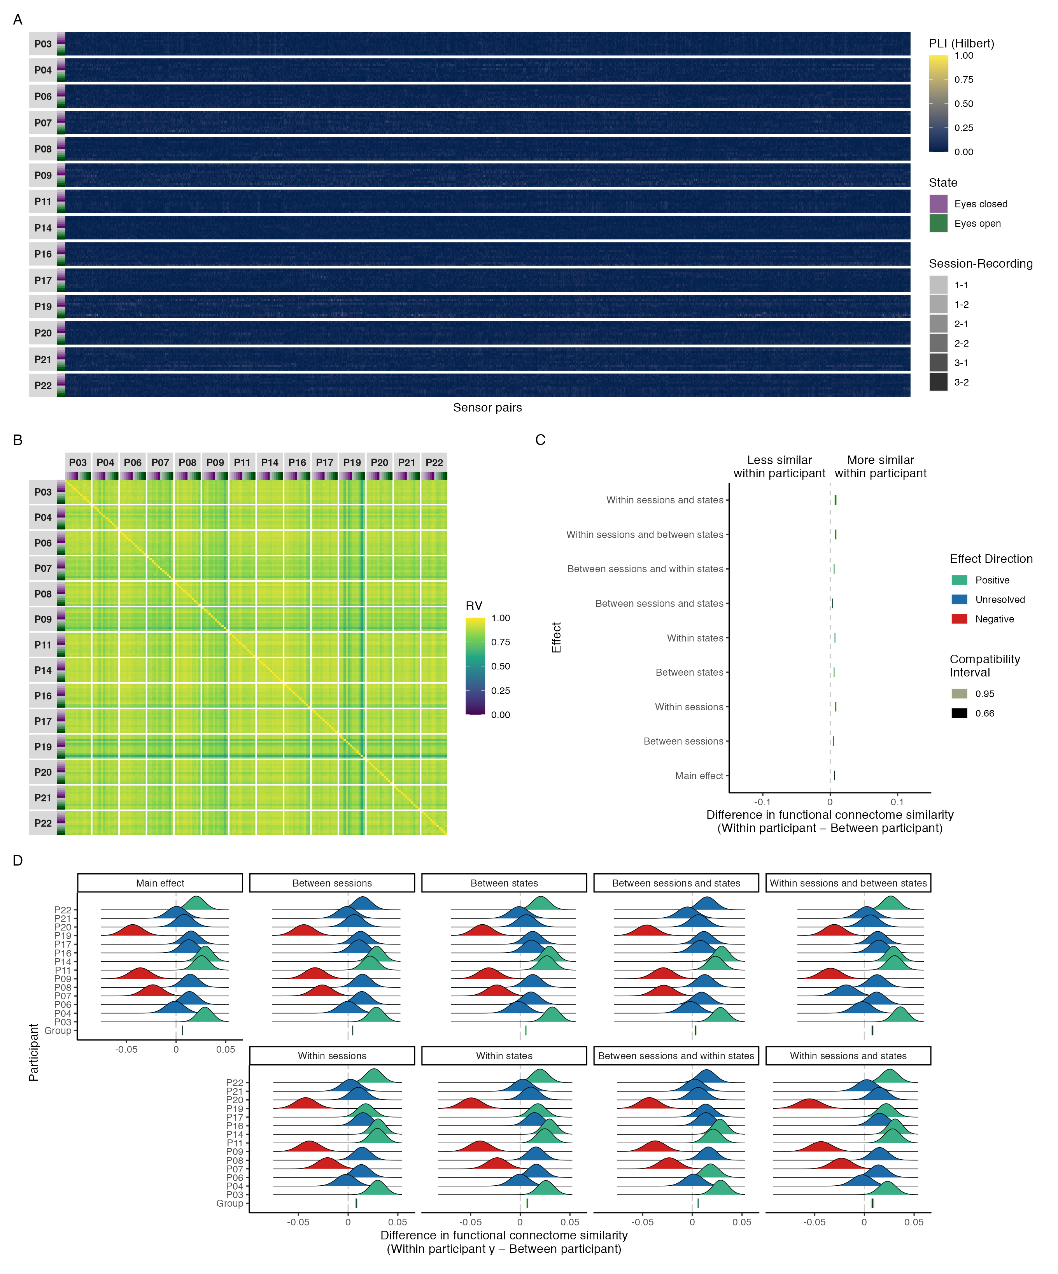

*Figure A1.*  Connectivity profile matrix (A), similarity matrix (B), interval plot (C), and ridge plots (D) for Hilbert phase coupling functional connectome similarities in the delta band.

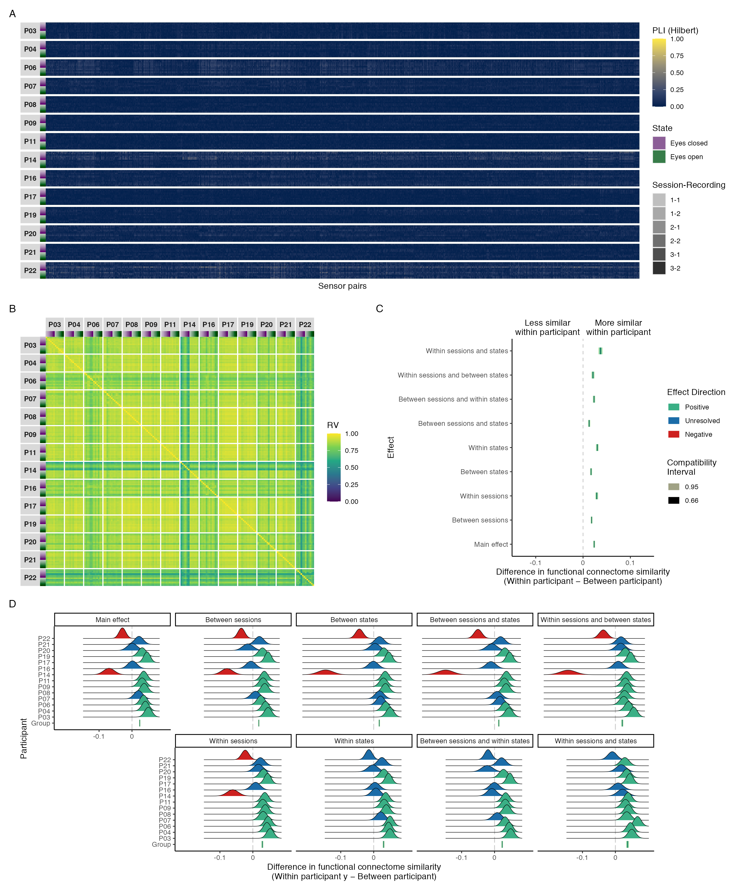

*Figure A2.*  Connectivity profile matrix (A), similarity matrix (B), interval plot (C), and ridge plots (D) for Hilbert phase coupling functional connectome similarities in the theta band.

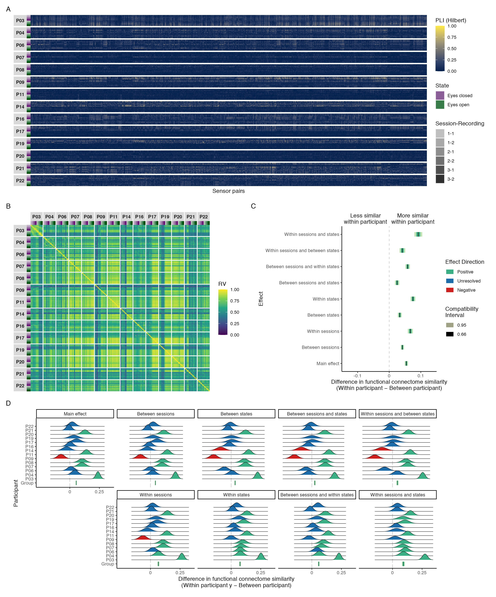

*Figure A3.*  Connectivity profile matrix (A), similarity matrix (B), interval plot (C), and ridge plots (D) for Hilbert phase coupling functional connectome similarities in the alpha band.

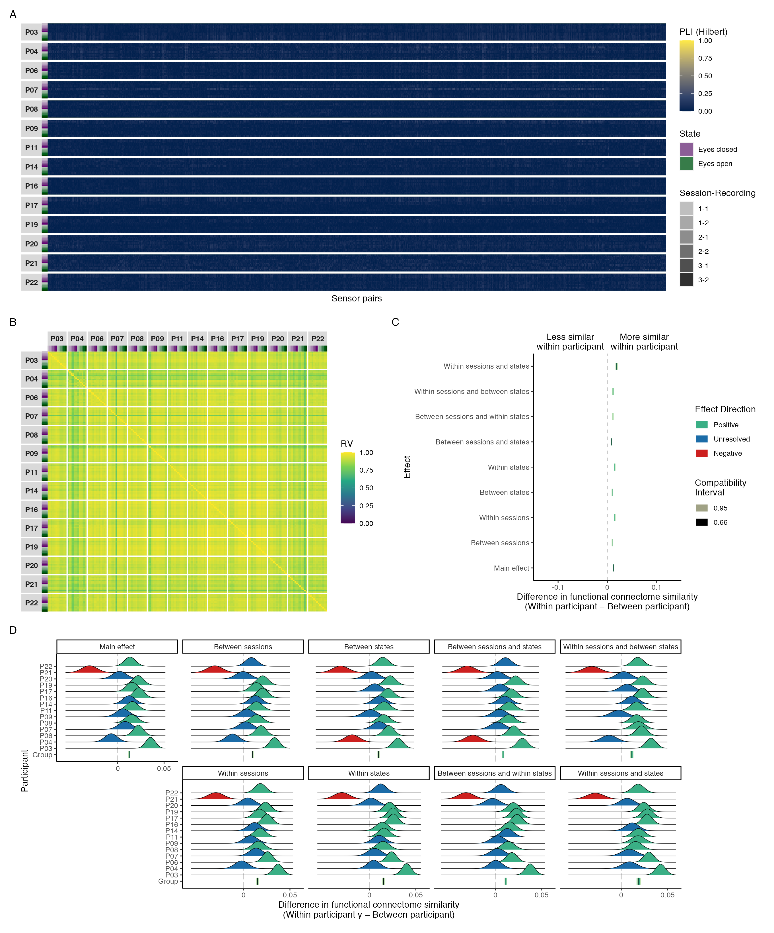

*Figure A4.*  Connectivity profile matrix (A), similarity matrix (B), interval plot (C), and ridge plots (D) for Hilbert phase coupling functional connectome similarities in the beta band.

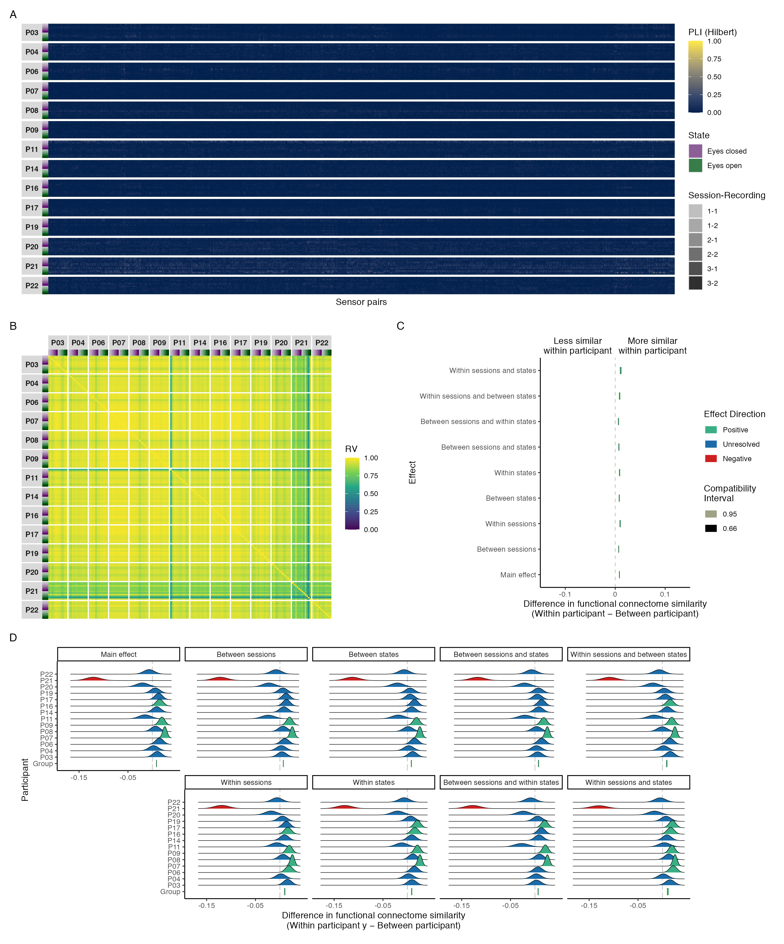

*Figure A5.*  Connectivity profile matrix (A), similarity matrix (B), interval plot (C), and ridge plots (D) for Hilbert phase coupling functional connectome similarities in the gamma band.

# Appendix B

Session Info

Table B1:

Session info for R environment.

| Setting | Value |
| --- | --- |
| version | R version 4.1.1 (2021-08-10) |
| os | macOS Mojave 10.14.6 |
| system | x86_64, darwin17.0 |
| ui | X11 |
| language | (EN) |
| collate | en_CA.UTF-8 |
| ctype | en_CA.UTF-8 |
| tz | America/Edmonton |
| date | 2022-07-27 |
| pandoc | 2.14.0.3 @ /Applications/RStudio.app/Contents/MacOS/pandoc/ (via rmarkdown) |
| python | 3.9 |

Table B2:

Session info for R packages.

| Package | Version | Source |
| --- | --- | --- |
| dplyr | 1.0.8 | CRAN (R 4.1.2) |
| emmeans | 1.7.3 | CRAN (R 4.1.2) |
| FactoMineR | 2.4 | CRAN (R 4.1.0) |
| forcats | 0.5.1 | CRAN (R 4.1.0) |
| fs | 1.5.2 | CRAN (R 4.1.0) |
| ggdist | 3.1.1.9001 | Github ([mjskay/ggdist@25a813d366ecf3ae4eff7e616f97de42f776a7a8](mailto:mjskay/ggdist@25a813d366ecf3ae4eff7e616f97de42f776a7a8)) |
| ggh4x | 0.2.1 | CRAN (R 4.1.0) |
| ggnewscale | 0.4.7 | CRAN (R 4.1.2) |
| ggplot2 | 3.3.5 | CRAN (R 4.1.0) |
| glmmTMB | 1.1.2 | local (/Users/userLTtC3fU2/glmmTMB_1.1.2.tar.gz) |
| here | 1.0.1 | CRAN (R 4.1.0) |
| papaja | 0.1.0.9999 | Github ([crsh/papaja@2572124f7cba193bbbaf02e6e5edcbcc0d3dfc8f](mailto:crsh/papaja@2572124f7cba193bbbaf02e6e5edcbcc0d3dfc8f)) |
| patchwork | 1.1.1 | CRAN (R 4.1.0) |
| performance | 0.9.0 | CRAN (R 4.1.2) |
| purrr | 0.3.4 | CRAN (R 4.1.0) |
| rbbt | 0.0.0.9000 | Github ([paleolimbot/rbbt@7c76fcca8ff29e4554910e631bfe24ffe5aac2de](mailto:paleolimbot/rbbt@7c76fcca8ff29e4554910e631bfe24ffe5aac2de)) |
| readr | 2.1.2 | CRAN (R 4.1.2) |
| reticulate | 1.25 | CRAN (R 4.1.2) |
| stringr | 1.4.0 | CRAN (R 4.1.0) |
| tarchetypes | 0.6.0 | CRAN (R 4.1.2) |
| targets | 0.12.0 | CRAN (R 4.1.2) |
| tibble | 3.1.6 | CRAN (R 4.1.0) |
| tidyr | 1.2.0 | CRAN (R 4.1.2) |
| tidyverse | 1.3.1 | CRAN (R 4.1.0) |
| tinylabels | 0.2.3 | CRAN (R 4.1.2) |

1. These values were obtained by back-transforming the Fisher-transformed Pearson correlation coefficients for the group and individual effects reported in Supplemental Figures 2D and 2E in Gratton et al. (2018), then taking their difference.
2. EEG biometrics research has demonstrated that resting state (eyes open and closed) functional connectomes from the same individual can be accurately matched when comparing a given individual’s connectome against all other connectomes in small samples (up to and around 100 participants; e.g., La Rocca et al., 2014). However, although findings like this do suggest that EEG functional connectomes are more similar within than between individuals—to a degree that allows for accurate matching—they do not address the magnitude of these individual differences. Thus, future work may find that EEG has sufficient spatial resolution for biometrics (where the size of individual differences do not matter, so long as they are consistent), but insufficient spatial resolution for studying network variants (where the size of individual differences are a focal interest).